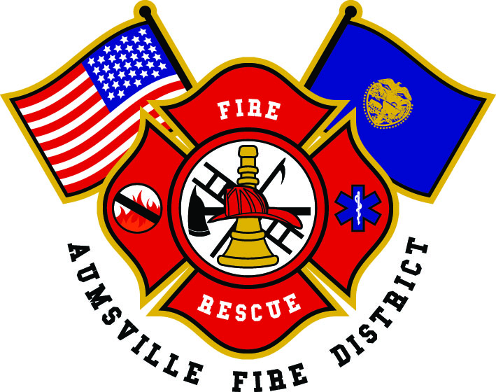
2022
Annual Report

Aumsville Rural Fire Protection District

Aumsville ✦ Shaw
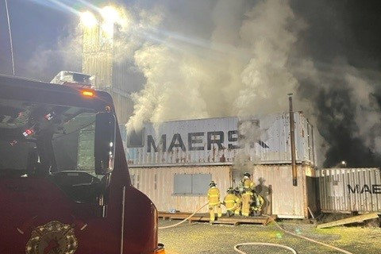
“Proudly Serving Since 1942”
___________________________________________________

Contents
Contents 1
Services We Provide 2
Organizational Chart 3
Financial Information 4
District Apparatus 5
Apparatus Maintenance Program 5
District Statistics 6
Year In Review 10

Services We Provide
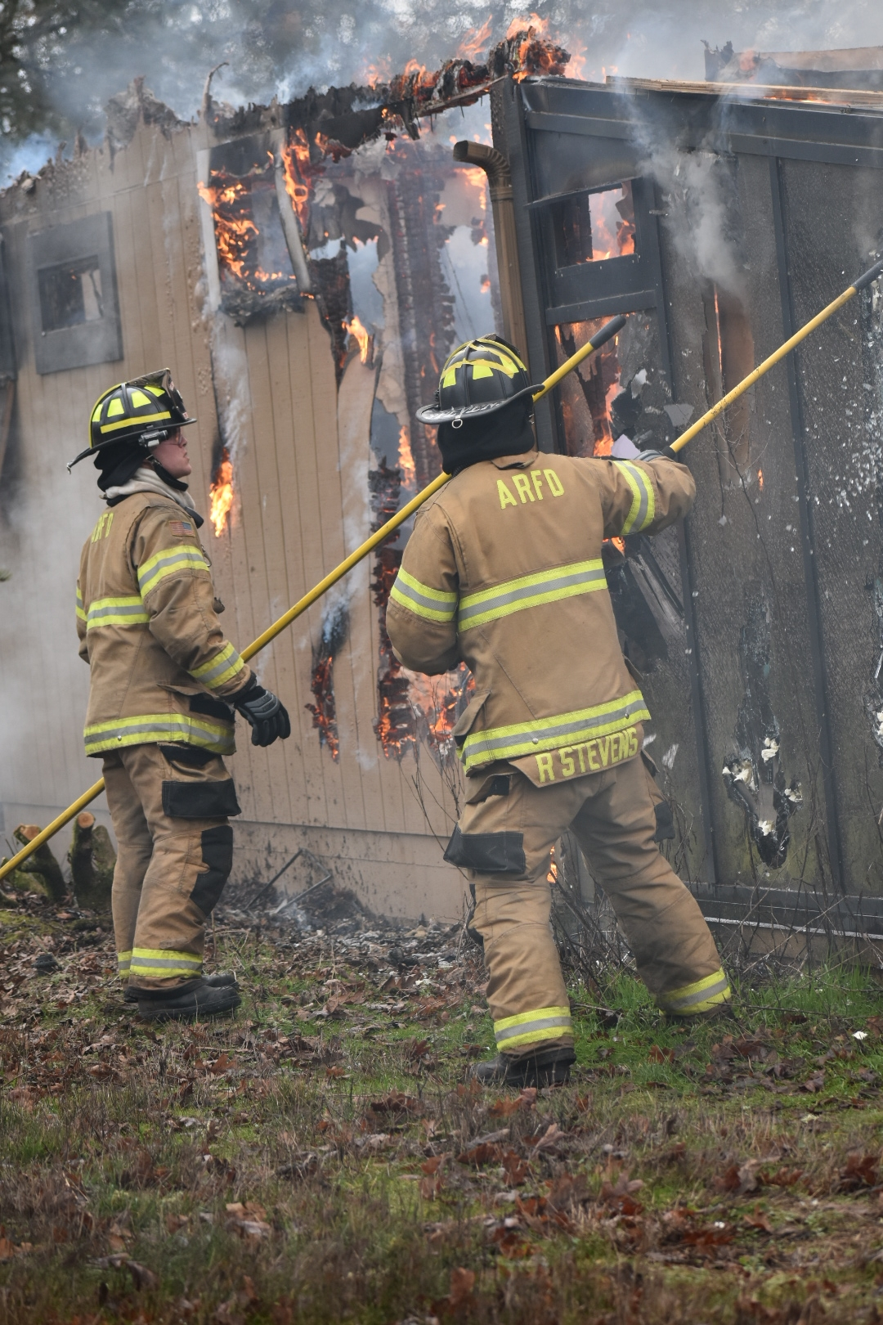
The Aumsville Rural Fire Protection District provides fire and emergency services to the City of Aumsville and the surrounding rural fire district, which is bordered by Sublimity, Turner, Silverton, Stayton, and Marion County Fire District #1. The district serves a population of approximately 7,200 people out of two strategically located Fire Stations. The district depends on a combination of volunteers and paid staff to respond to emergency calls.
The Aumsville Volunteer Fire Department was first organized in the early 1930’s with a crew of volunteer citizens under the leadership of Sam Weis. The Aumsville Rural Fire Protection District was formed in 1942 and is considered a Special District under Oregon Revised Statute 478. The district covers approximately 24 square miles, including the communities of Aumsville and Shaw. The response area includes both suburban and rural environments. City and District areas alike are experiencing significant growth in housing and commercial/industrial construction.
The Aumsville Rural Fire District is an all-hazards response agency and handles fire suppression, emergency medical services, hazardous materials response, fire prevention, fire safety education, and health education on injury and illness prevention for our community.
There are two fire stations within the district located in Aumsville and Shaw that are primarily staffed with volunteers. The volunteers are dedicated, service-oriented people who reside or work within the district boundaries and are willing to go through an extensive training program in order to serve as a member of the Aumsville Rural Fire Protection District. Community members interested in volunteering should contact the Fire District office.
The combination of volunteer and career personnel include the Fire Chief, Training Captain, Office Administrator, five part-time firefighters several volunteers including firefighters, EMS personnel, cadets, and District Link Support.
The district operates two fire engines (750 gallon), two 3000-gallon tenders, one 750-gallon brush truck and one 500-gallon brush truck, three light duty rescues, and one command unit out of the two stations. A combination of career and volunteer personnel staff a single command unit within the district 24/7.

Organizational Chart
Officers
Lt/EMT Eric Pineda
District Link Support
Jeanne Barnes
Nico Casarez
Debbie Denton
Cindy Gordon
Barbara Jackson
Buffie Morrison
Elizabeth Parker
Nettie Yechout
Staff
FF/EMT Jenn Bratton
FF/EMT Garrett Bibeau
FF/EMT Brandon Bishop
FF/EMR Brad Buchholz
FF/EMR Roberto Delamontaigne
Recruit/EMR Robie Dysinger
Recruit Chris Frank
Recruit/EMT Jeremy Hereford
FF/EMT Rodney Lutgen
Recruit Shawn Mahmood
FF/EMR Tyler Marquez
FF/EMT Brynn Nelson
FF/EMT Brenden Nipp
FF/EMT Daniel Reyes
FF/EMT Tyler Schlauderaff
Recruit Connor Stapleton
FF/EMT Tommy Terrones

Fire Chief/EMT
(Executive Officer)
Roy Hari
Budget/Policy/Planning
Public Information Officer
Cadets

Tender Drivers
Andy Angstrom
EMT Rodney Lutgen
Trish Lutgen
Sam Pietzold
Todd Raska
Training Captain/Paramedic
Brad McKenzie
District Training Officer
EMS Coordinator
OSHA Compliance Officer
Building Maintenance
Vehicle Maintenance
Office Administrator/EMR
Trish Lutgen
Billing
Budget
Business Office
Information Management
Payroll
Support Team Coordinator
Aumsville Board of Directors
Joshua Phillis, Position #1
P
Aumsville Station
650
490 Church Street
Shaw Station
670
5604 Shaw Hwy SE
Rachel Fellis, Position #2
P
Matthew Etzel, Position #5
P
Wayne Kuhl, Position #4
P
Robert Garrison, Position #3
P

Financial Information
An annual financial audit provides the district and the public with an accounting of the Fire District’s finances. The district operates on a cash basis. As part of obtaining reasonable assurance about whether the district’s financial statements are free of material misstatement, tests are performed for compliance with certain provisions of laws, regulations, contracts, and grants, including the provisions of Oregon Revised Statutes, as specified in Oregon Administrative Rules 162-010-0000 through 162-010-0320.
Accuity, the district auditors, report that the 2021-22 audit indicated our financial statements present fairly, in all material respects, the respective modified cash basis financial position of the governmental activities, each major fund, and the aggregate remaining fund information for Aumsville Rural Fire Protection District. However, due to the limited number of staff, many critical accounting duties have been combined. While the District has procedures in place to monitor areas where there is a lack of segregation of duties, there is inadequate monitoring relating to internal controls. Our General Fund ended with a balance of $535,724.00, and we made transfers to our fund accounts totaling $40,000.
The 2021-22 Budget Committee Members were as follows: Cindy Gordon, Matthew Etzel, Kathryn Nichol, Nico Casarez, and Crystal Kluver. The Budget Officer is Chief Roy Hari.
2021-22 Assessed Value
Marion County $583,180,983
Permanent Tax Rate: 1.3612 per thousand
Bond Rate: .4318 per thousand
Fund | 2021-22 Budget
General Fund | $1,516,063
Debt Service Fund | $ 276,257
Apparatus Fund | $ 55,841
Equipment Fund | $ 43,359
Property & Facilities Fund | $ 105,672

Fiscal Year | Total Real Market Value¹ | M5 Real Market Value² | Total Assessed Value (AV)³ | AV Used to Calculate Rates | Total Rate/$1,000 of Assessed Value | Total Taxes for Distribution⁴
2021-22 | $1,161,994,350 | $1,069,050,830 | $583,180,983 | $583,180,983 | $1.8429 | $1,078,405.96
2020-21 | 1,053,820,750 | 904,025,885 | 555,069,300 | 555,069,300 | 1.7930 | 996,094.94
2019-20 | 973,447,870 | 825,324,093 | 527,013,478 | 527,013,478 | 1.8159 | 960,383.55
2018-19 | 888,230,529 | 756,580,225 | 491,273,325 | 491,273,325 | 1.8490 | 931,975.91
2017-18 | 793,128,715 |  | 470,452,121 | 470,452,121 | 1.8456 | 869,223.32
2016-17 | 740,895,542 | 613,925,177 | 453,875,421 | 453,875,421 | 1.8519 | 841,981.65
2015-16 | 682,173,716 | 550,505,951 | 437,725,772 | 437,725,772 | 1.8592 | 815,037.79
2014-15 | 655,183,512 | 525,285,498 | 422,218,203 | 422,218,203 | 1.8889 | 801,799.29
2013-14 | 603,896,032 | 489,854,345 | 404,430,345 | 404,430,345 | 1.8721 | 757,317.52
2012-13 | 613,931,787 |  | 389,387,016 | 389,387,016 | 1.8728 | 729,244.10
2011-12 | 622,991,252 |  | 381,560,081 | 381,560,081 | 1.8674 | 713,197.06
2010-11 | 662,453,287 |  | 369,638,520 | 369,638,520 | 1.8610 | 689,593.75
¹ This is the Real Market Value for all properties before any adjustments for exemptions and specially assessed properties.
² Value represents the Real Market Value of taxable properties, including the reduction in in Real Market Value of specially assessed properties such as farm and forestland. This value is also commonly referred to as the Measure 5 Real Market Value by county assessors.
³ Includes the Urban Renewal Excess Value.
⁴ Total Adjustments – Amount reflects special assessments being allocated to proper districts plus buyouts for Marion County.
Source: Marion County Department of Assessment and Taxation

District Apparatus
Apparatus | Year | Make/Model | Location
Command 65 | 2016 | Ford Explorer | Aumsville Station 650
Rescue 66 | 2016 | Ford Explorer | Aumsville Station 650
Rescue 67 | 2008 | Ford F-350 | Shaw Station 670
Brush 65 | 2016 | Rosenbauer Timberwolf | Aumsville Station 650
Brush 67 | 2016 | Rosenbauer Timberwolf | Shaw Station 670
Engine 65 | 2016 | Pierce Impel | Aumsville Station 650
Engine 66 | 2016 | Pierce Impel | Aumsville Station 650
Tender 65 | 2002 | KME FL112 | Aumsville Station 650
Tender 67 | 2002 | KME FL112 | Shaw Station 670
Utility 65 | 2020 | Ford F-150 | Aumsville Station 650

Apparatus Maintenance Program
In 2017, in accordance with ORS Chapter 478, Aumsville Rural Fire District entered into Intergovernmental agreements with the following districts:
- Drakes Crossing,
- Lyons Fire District,
- Sublimity Fire District,
- Turner Fire District.
In 2018, in accordance with ORS Chapter 478, Aumsville Rural Fire District entered into Intergovernmental agreements with the following:
- Aumsville Police Department
- Aumsville Public Works
The agreements state that all parties will utilize Aumsville Rural Fire Protection District Apparatus Maintenance Program and is entered into under the authority granted to the parties by ORS 190.010, which authorizes units of local governments to enter into written agreements with any other units of local government for the performance of activities or functions. This maintenance program assists the district in the ability to employ a full-time firefighter/mechanic.
The program had its first increase in labor rates from $50 to $70 per hour for 2019.

District Statistics
The Aumsville Rural Fire District responded to a total of 820 calls for service in 2022. These consisted of fires, medical emergencies, motor-vehicle crashes, and a variety of miscellaneous calls. The district had a 8.48% decrease in service for 2022, a 10-year history of call volume shown here indicates a 40.89% increase in demand for service.

Total Fire & EMS Calls the District Responds to Annually

2022 Calls by Type
Call types are determined by categories established by the National Fire Incident Reporting System operated by the U.S. Fire Administration, a division of the Federal Department of Homeland Security. The information from our database becomes part of the National Fire Data Center reports and results in specific control measures when fire data indicates specific problems. Aumsville is very similar to most other departments in that the highest number of calls are medical and rescue related, followed by service and good intent calls.

2022 Monthly Calls Compared to the Yearly Average
Emergency responses vary by month. Our average monthly call volume was 68.33 calls. During the summer months the district is busier due to wildland fires and recreational activities, while our winter months bring more incidents involving heating equipment and poor road conditions. December shows a high call volume compared to other months due to the local ice storm.
The district averaged 2.59 responders per call in 2022. In 2021, the responders per call was an average of 2.09. This is a 23.92% increase in personnel per call. In 2021, 36.09% of the calls had a response time in under five minutes and 82.71% of the calls had a response in under ten minutes. Aumsville currently does not offer a sleeper program, so the response time increases in the evening and early morning hours as volunteers respond from home. There are plans to add a sleeper program to decrease the response times; however, this will require the addition of living and sleeping quarters. Temporary sleeping provisions have been added to the Aumsville Station as a stopgap measure to enhance the efficacy of our current staffing model.
Evaluating data has played an important factor in determining staffing needs. One of the biggest changes occurred in 2017 and was entirely data-driven, the district moved to having a part-time Fire Chief and hired three part-time firefighters.
The district continues to monitor the call volume. The data paints a clear picture when the busiest days occur. For the last two years the days of the week with the heaviest call volume are Wednesday and Friday.

2022 Annual Call Volume by Day of Week
The chart below shows the daily call times by the hour. As is typical with most departments, Aumsville is busiest during the daytime. This is also the time when volunteers are least available to respond, as most either work or go to school during daytime hours.

2022 Call Volume by the Hour
As a result of this data in 2017, the Chief determined that additional personnel were needed during the day, and with limited budget resources to work with, he chose to trade the full-time, 5-day-per-week Chief position to a part-time position that would cover one day of the week. This freed up finances to allow the district to hire 3 part-time employees who work 24 hours over two to three shifts each during the busiest hours each day. In 2021, the district added two additional on-call people to work shifts when others could not. In 2022, the district adjusted shifts and added three additional part-time staff when the mechanic left the agency.
This unique staffing schedule provides a minimum of 3 response personnel in the station during the day, five days per week, and one person in the station on weekends, which is a significant improvement over previous staffing.
As with most volunteer and combination fire departments, the district has a strong social network and provides a welcoming atmosphere for our personnel. The district hosts several community functions throughout the year and constantly explore ways to improve our organization. Volunteers are recognized for their efforts at an annual awards ceremony.
The district has several programs designed to give our citizens the opportunity to volunteer that do not include the rigorous demands of fire training or response. The Tender Operator Program utilizes persons capable of driving water tenders to the scene of rural fires. The Cadet program is for youth between the ages of 16 -18 which offers youth the opportunity to learn about being a firefighter. The Support Team not only supports the firefighters when they are on scene, but they help put on the community events and raise funds for needed equipment.
District Personal
Title | Staff or Volunteer | Staff Full-Time Equivalent
Administration | Staff | 2.5
Firefighters | Staff | 3.7
Lieutenants | Volunteer | 0
Firefighters | Volunteer | 7
Tender Driver Program | Volunteer | 4
Recruit | Volunteer | 5
Cadet | Volunteer | 1
Support Team | Volunteer | 8

Volunteers are the backbone of our delivery model. If you, or anyone you know are interested in becoming a volunteer firefighter, do not hesitate to stop in at the Aumsville Station and talk with any one of our personnel. We welcome interested people!

Year In Review
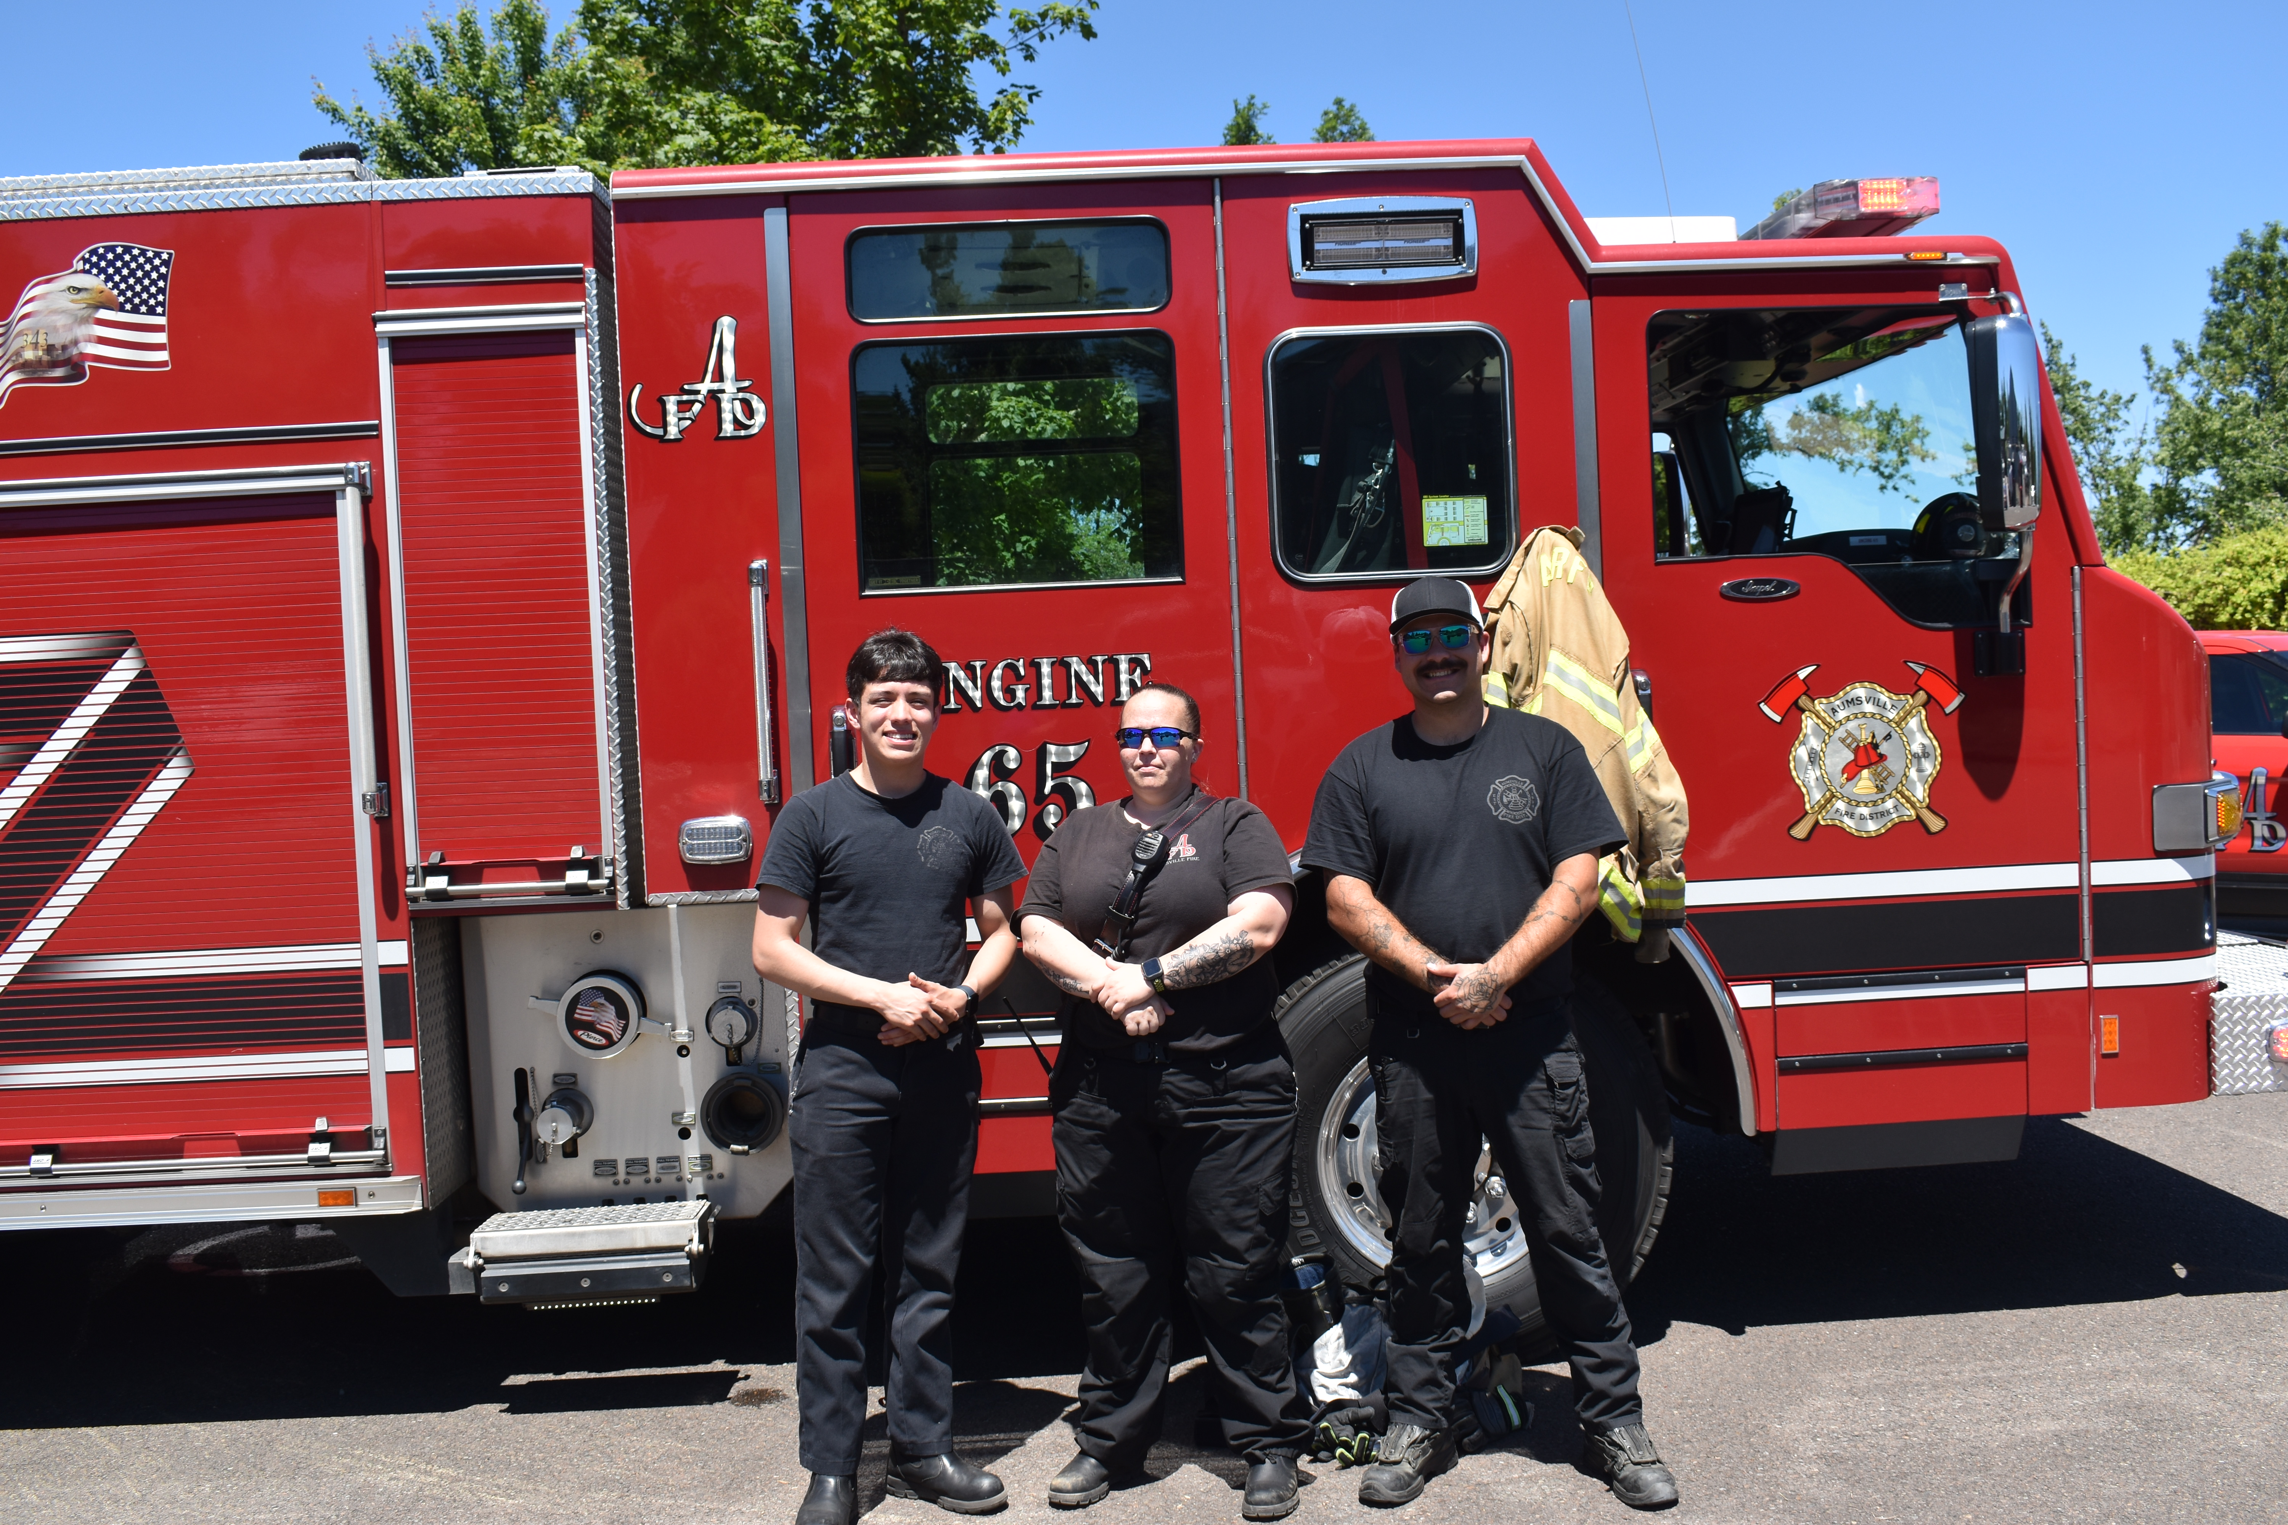
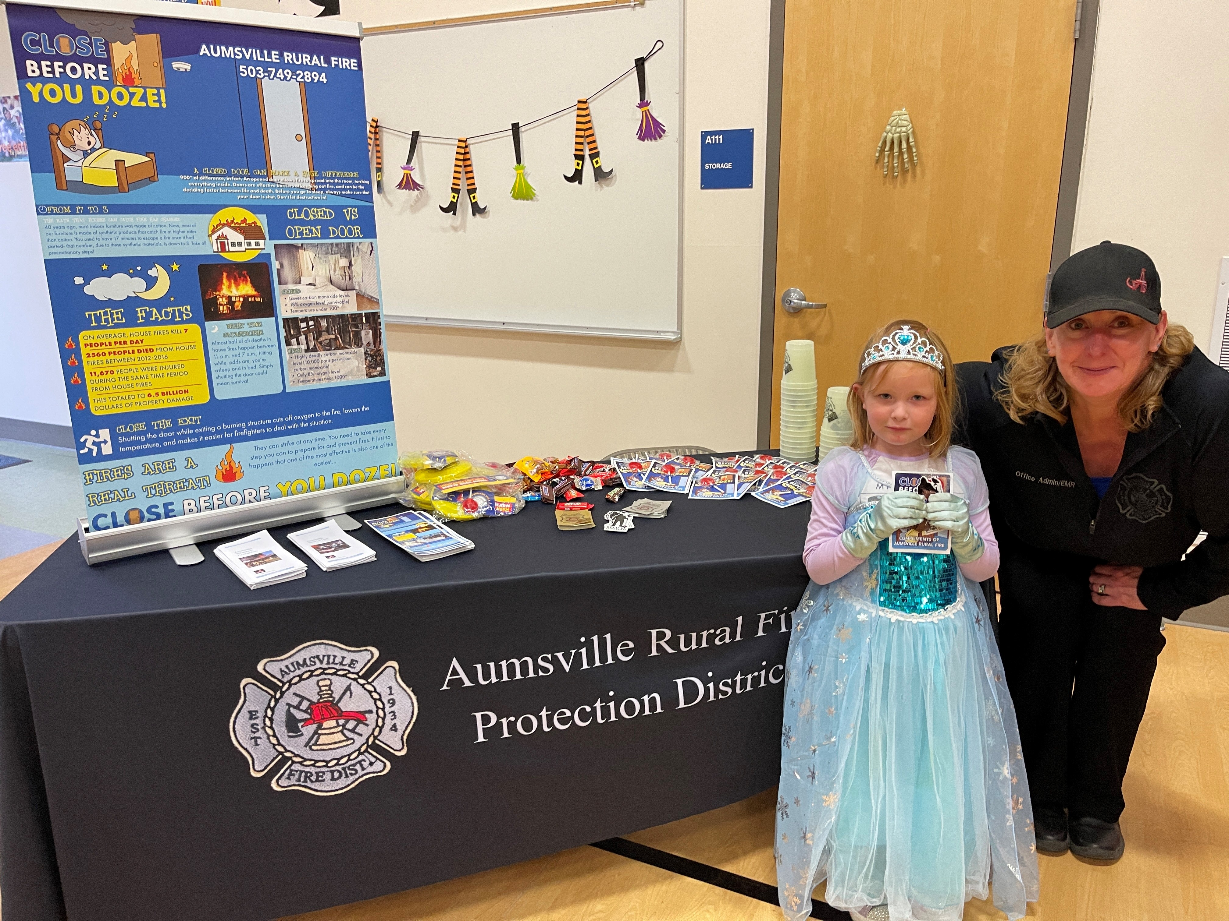✦
Superhero Day at the Park
Harvest Party at the Elementary School
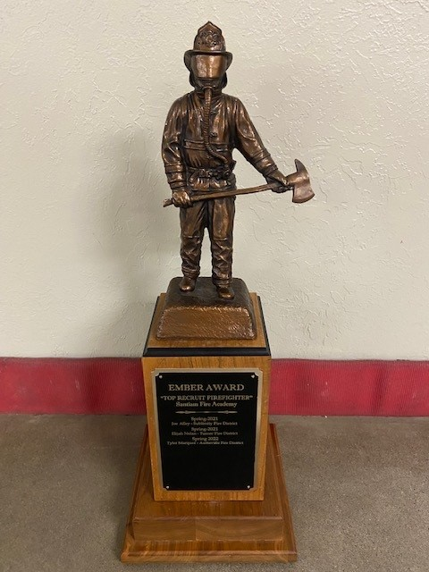
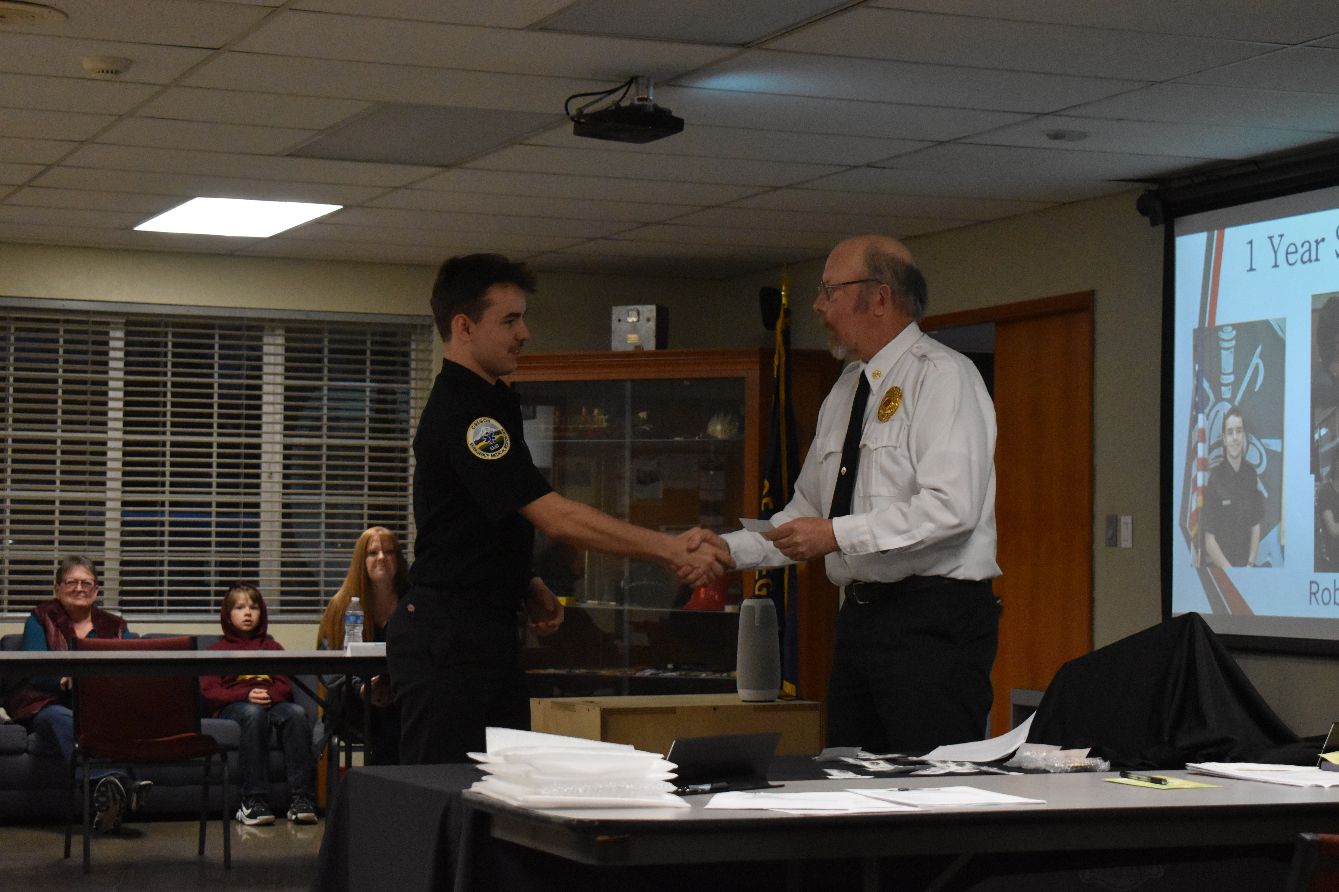
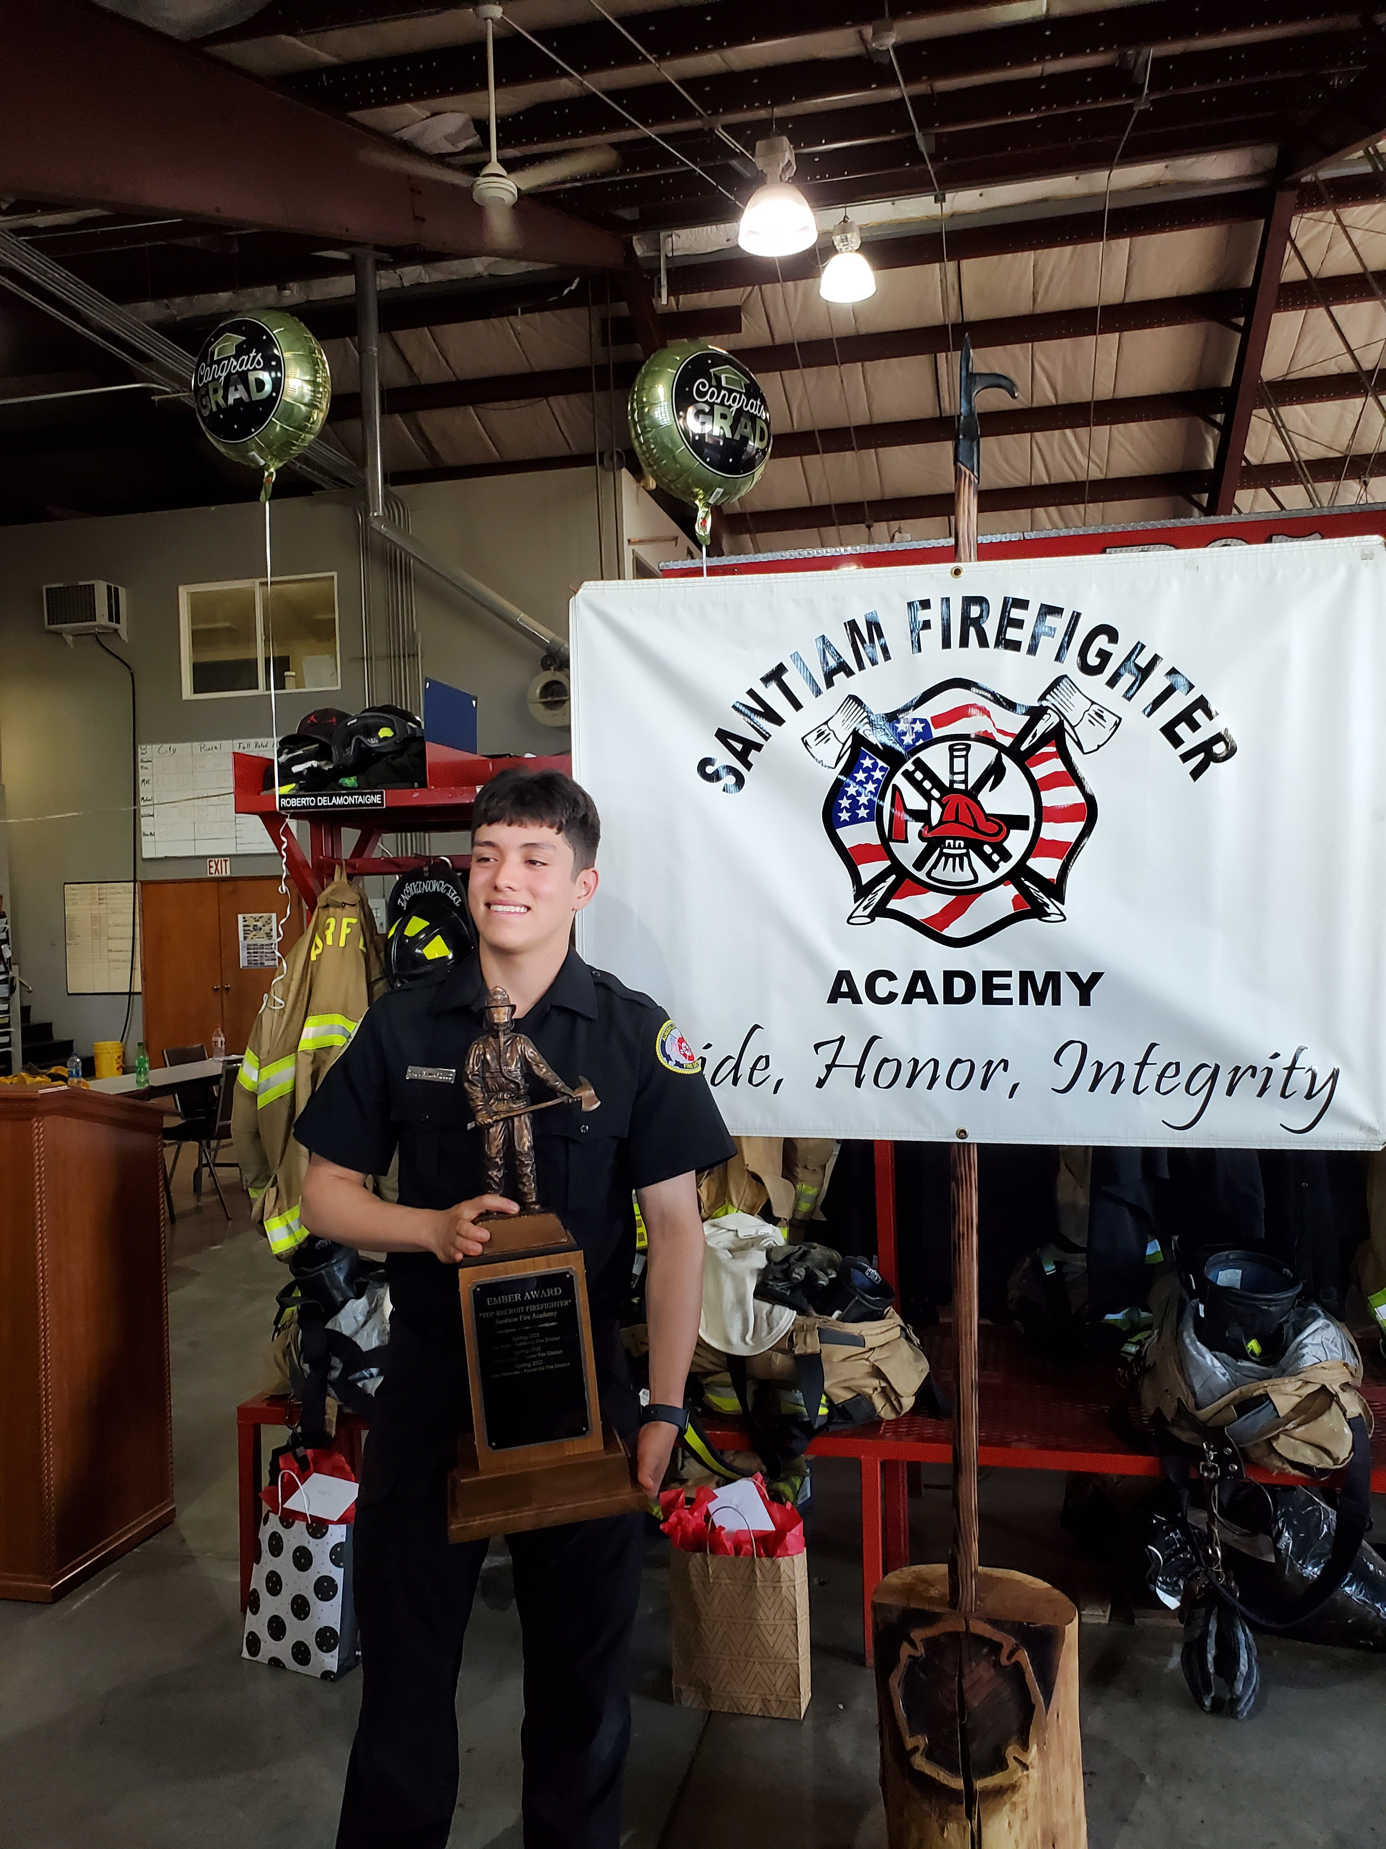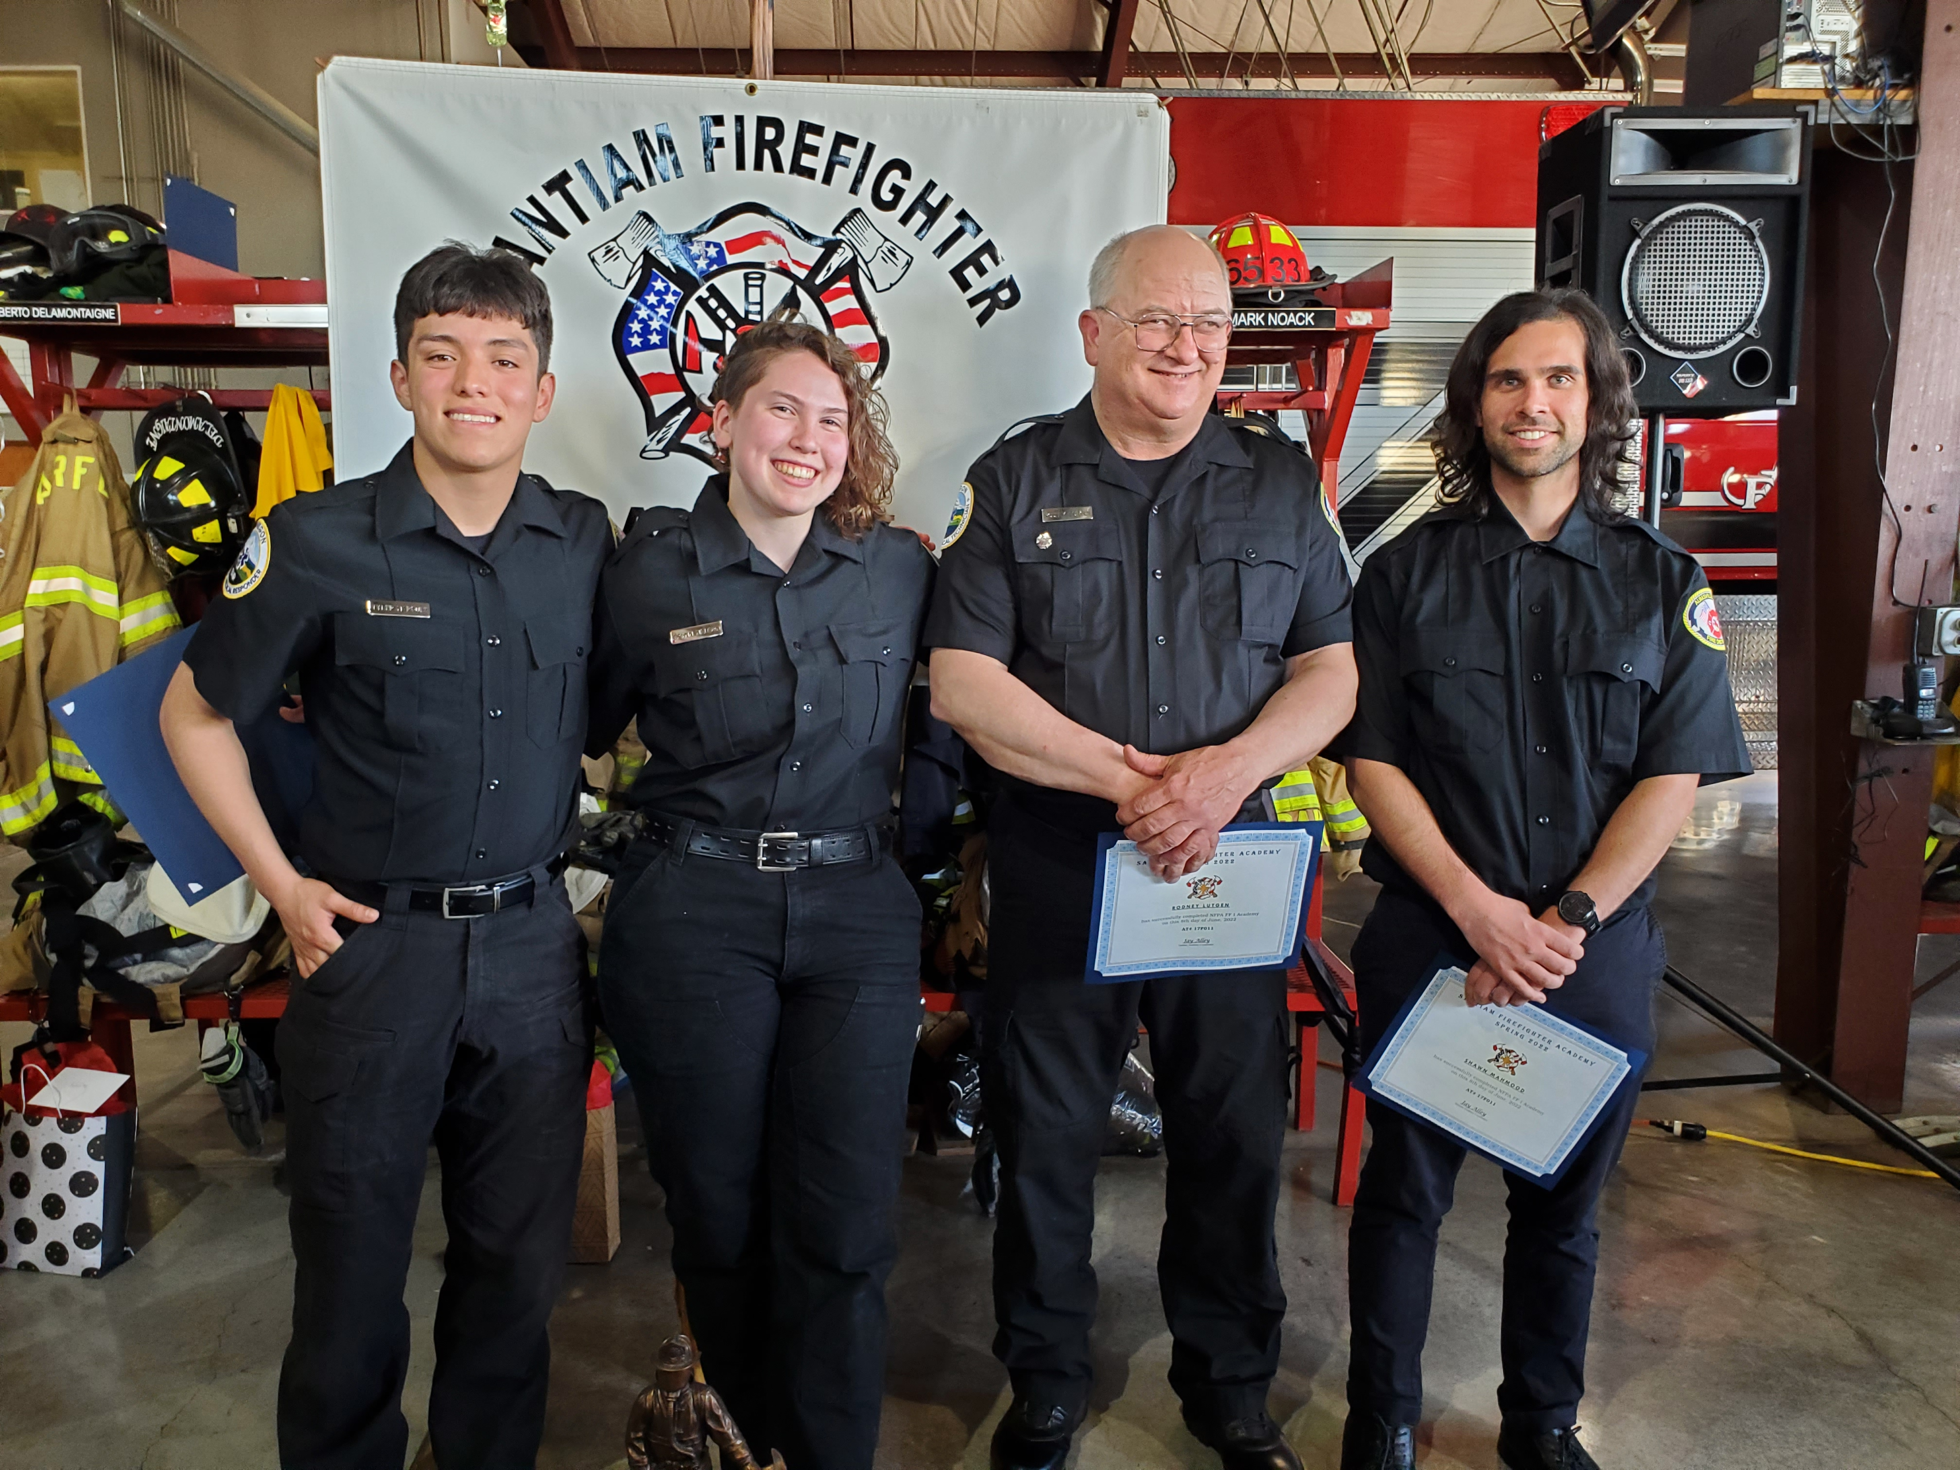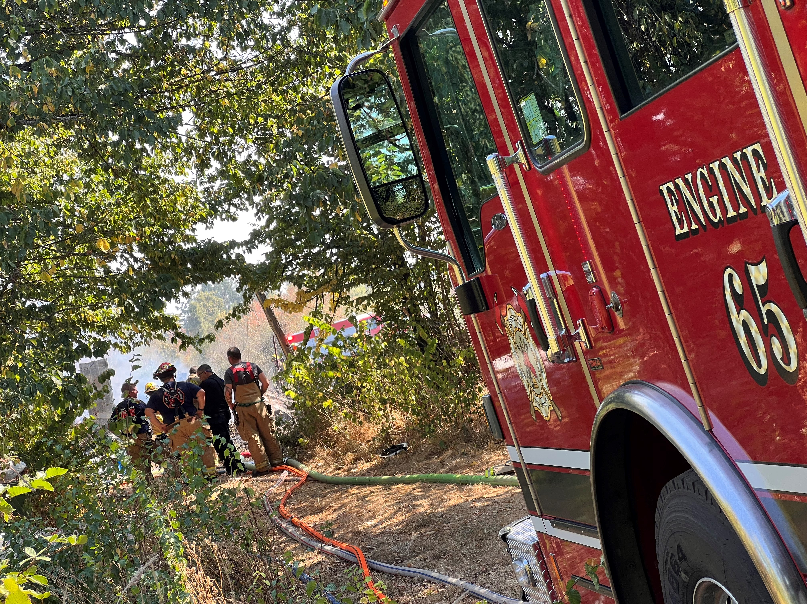
2022 Fire Academy Graduates
2022 Ember Award Recipient, Tyler Marquez
