Annual Budget

Proposed
Fiscal Year 2023-2024

Aumsville Rural Fire Protection District
Oregon
July 1, 2023 – June 30, 2024

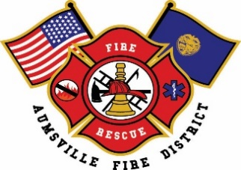

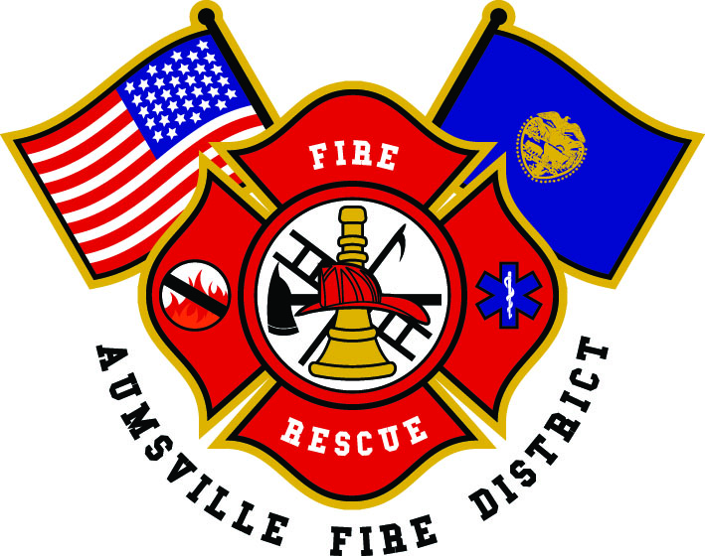
Aumsville Rural Fire Protection District
Table of Contents
Introduction 1
Budget Committee Roster 2
GFOA Budget Presentation Award 3
District History 4
Geographical Information 5
Population & Demographics 6
Fire Stations & Property 6
Services & Equipment Provided 8
Personnel Services 8
Organizational Chart 10
Budget Message 11
Strategic Planning 13
Planning Process 14
Challenges 15
Mission, Vision, and Values 16
Strategic Plan Framework 16
Budget Summary 21
Budget Process 22
Budget Calendar 22
Summary of Steps 23
Budgeting, Accounting and Financial Reporting Method 24
Revenues 25
Expenditures 25
Minimum Fund Balance Policy 28
Schedule of Appropriations 31
Resources 33
Property Taxes 35
Beginning Fund Balance 36
Grant Revenue 36
Other Revenue Sources 37
Requirements 39
General Fund – Fund 1 40
General Fund Resources 41
General Fund Expenditures 43
Personnel Services 46
Materials and Services 47
Capital Outlay 48
Debt Service 48
Ending Fund Balance and Operating Contingency 48
Fund Summary 49
Debt Service Fund 2 50
Apparatus Fund 4 51
Equipment Fund 6 52
Property & Facilities Fund 7 52
Accounting Policies and Procedures 55
Introduction 56
Division of Duties 56
Cash Receipts Procedures 57
Cash Disbursement Procedures 58
Reconciliations 59
Purchases 59
Payroll 61
Financial Reporting 62
Fund Balance Reporting Policy (GASB54) 62
Financial Management Policy 63
Objectives 63
Banking Services 63
Check Signing 64
Billing and Receipts 64
State Funds/State Grants 64
Cash Forecasting 64
Debt 65
Audits/Auditors 65
Internal Controls 65
Financial Responsibilities 66
Credit Card Use 67
Overview 67
Card Usage 68
Procedures/Records 70
Potential Problems 71
Additional Cardholder Responsibilities 71
Misuse 72
Purchasing Policy 73
Purpose 73
Procedure 73
Documentation 74
Capitalization of Fixed Assets 75
Purpose 75
Definitions 75
Depreciation Schedules 76
Listing of Inventory 76
Debt Management Policy 76
Investment Policy 77
Purpose 77
General Objectives 77
Standards of Care 78
Safekeeping and Custody 79
Suitable and Authorized Investments 80
Investment Parameters 81
Reporting 82
Policy Adoption and Re-Adoption 83
List of Documents Used in Conjunction with this Policy 83
Glossary 86

Introduction

Budget Committee Roster

Board Members Term Expiration
Robert Garrison, President | June 30, 2025
Wayne “Dusty” Kuhl, Vice President | June 30, 2023
Rachel Fellis, Secretary/Treasurer | June 30, 2025
Joshua Phillis, Director | June 30, 2023
Matthew Etzel, Director | June 30, 2023

Citizen Members Term Expiration
Nico Casarez | June 30, 2024
Jennifer Elliott | June 30, 2024
Matt Dryden | June 30, 2023
Tammy Bennett | June 30, 2025
Katheryn Nichol | June 30, 2025

Fire District Administration
Roy Hari, Fire Chief/Budget Officer
Trish Lutgen, Office Administrator

GFOA Budget Presentation Award
Government Finance Officers Association of the United States and Canada (GFOA) presented a Distinguished Budget Presentation Award to Aumsville Rural Fire Protection District, Oregon, for its Annual Budget for the fiscal year beginning July 01, 2022. In order to receive this award, a governmental unit must publish a budget document that meets program criteria as a policy document, as a financial plan, as an operations guide, and as a communications device.

This award is valid for a period of one year only. We believe our current budget continues to conform to program requirements, and we are submitting it to GFOA to determine its eligibility for another award.

District History
The Aumsville Volunteer Fire Department was first organized in the early 1930’s with a crew of volunteer citizens under the leadership of Sam Weis. The first equipment available was two soda and acid tanks mounted on a handcart and the members pulled it by hand to the scene of the fire.

In 1937 the first vehicle was purchased. It was a 1934 Chevrolet truck on which a pump and storage tanks were installed by the late D.L. Eastburn in his machine shop.

The Aumsville Rural Fire Protection District was formed in 1942 and is organized as a Special District under Oregon Revised Statute 478. The City of Aumsville contracted with the district to provide fire protection services.

In 1947 a special election was held to seek approval for a general obligation bond totaling $10,000. The bond was used to purchase new fire equipment and a “Diamond T” pumper. The bond was paid off in ten years.

The district received approval for a bond in 2015. The bond allowed the district to replace three engines and two brush trucks with two Type 1 engines and two Type 3 brush trucks.

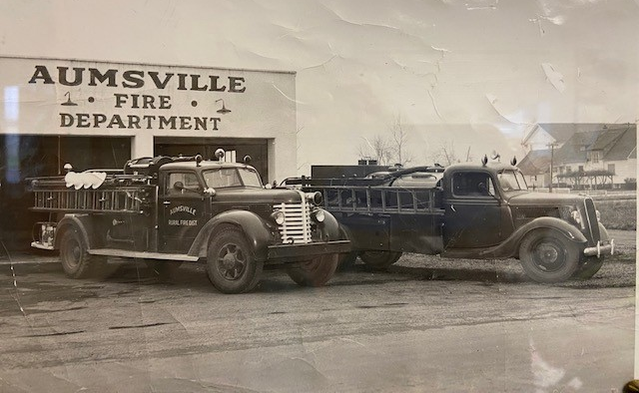
In 2019 the district purchased a piece of property across the street from the main station. The intent of the purchase was to ensure future expansion of the administrative, living, meeting, and training areas that are currently inadequate to accommodate the needs of the district.

Geographical Information
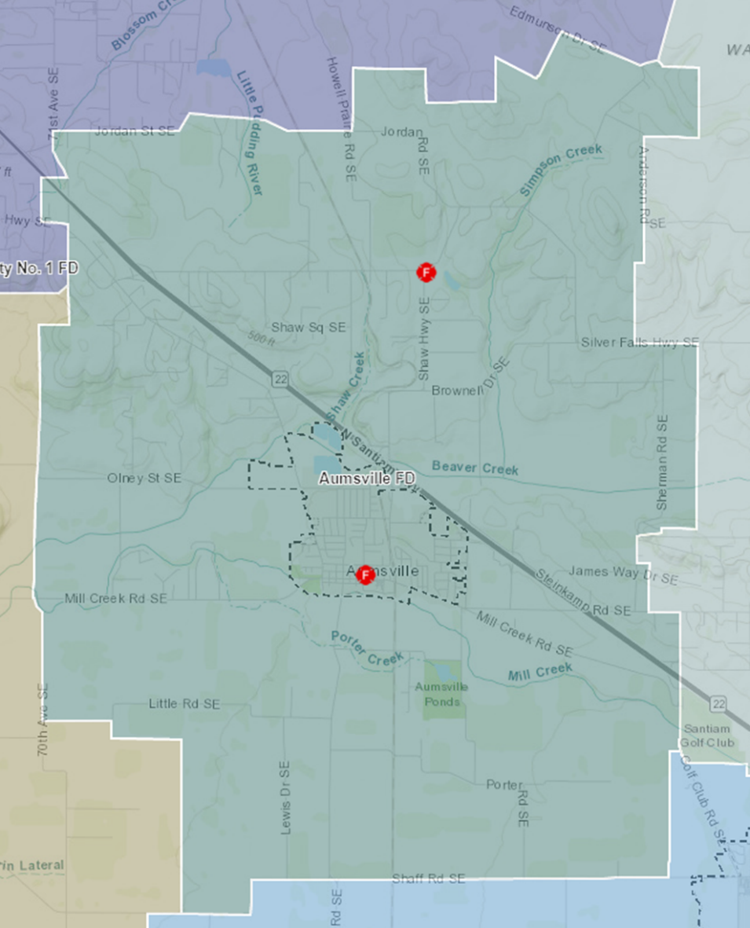
Aumsville Rural Fire Protection District (ARFPD) is a special taxing district organized under ORS. 478. The district is located in the foothills of the Cascade Mountain range in Marion County, Oregon. The boundaries of the district cover 15,629 acres, or 24.42 square miles. Highway 22 runs diagonally through the center of the district, which sees an annual average daily traffic count of 22,331. ARFPD provides emergency response to the City of Aumsville, located to the south of HWY 22, and to the unincorporated community of Shaw located north of HWY 22. The district is bisected north and south by an inactive spur of the Willamette Valley Railroad.

Population & Demographics
Because ARFPD is a special taxing district, it is difficult to get accurate data due to the district boundaries encompassing a rural area in addition to a city. Census data is available but is only provided at the City level. Estimates can be obtained by utilizing counts from the Marion County Tax Assessor’s office. For the 2022-23 tax year, Marion County Tax Assessor shows ARFPD serves 1,333 residential households, 1,326 rural households and 218 commercial tax accounts. There are an additional 389 land and utility tax accounts. (Please note that due to a data conversion at the Marion County Tax Assessor’s office data remains inconsistent.)
Utilizing the US average of people per household of 2.6, we can estimate the current population of the fire district’s community as 6913. The median age is 31.2 years.

According to https://worldpopulationreview.com/us-cities/aumsville-or-population, the 2023 poverty rate for the City of Aumsville is 23.7%. For the female population the poverty rate is 18.05%, and the poverty rate for males is 18.06%. Hispanics are more likely to be in poverty with a rate of 37.61%. In any case, approximately one out of four people in our community live in poverty.

2019 saw the completion of a new development which brought approximately 30 new homes to Aumsville. 2022 brings the completion of a lite industrial warehouse along with two requests for zoning changes that will allow for continued commercial growth. Per Zillow.com for 2023 the typical home value in the Aumsville area is $437,335, which is up 2.1% over the past year.

Aumsville has had a population growth of 14.3% since 2020; however, it has seen the job market decrease by -0.1% over the last year according to a report from bestplaces.net. The cost of living is 2.1% higher than the national average. The median income of an Aumsville resident is $50,319 a year.

Fire Stations & Property
ARFPD operates two stations. The main station is located at 490 Church Street in Aumsville. It was built in 1975 and is 21,780 square feet. Designed originally as an all-volunteer station with minimal space for offices, the main station has since been retrofitted by volunteer personnel to accommodate office areas for a Chief, Training Officer, FF/Maintenance officer, and Office staff.
The Shaw station is located at 5604 Shaw Hwy SE, Aumsville. The 2.64 acres of property was obtained in 1982 and the building was built in 1985. The station grounds are where much of the district’s hands-on training is provided. There is a small pond located at the east end of the Shaw Fire Station grounds.
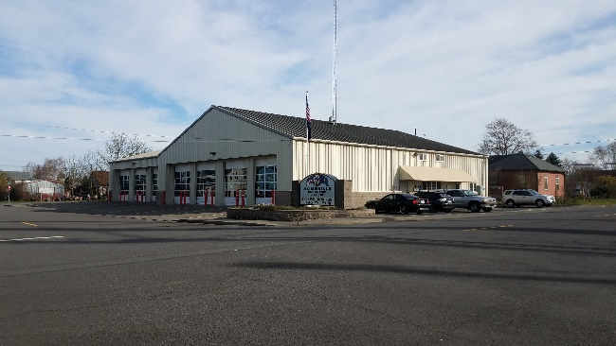 | 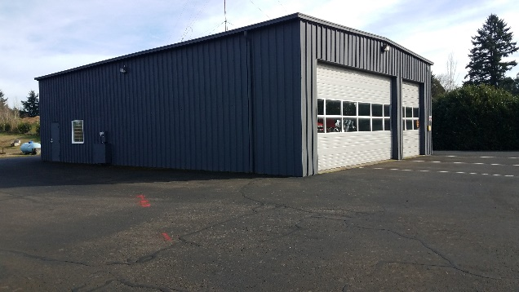
Aumsville Station | Shaw Station

In 2019 the district purchased the property adjacent to the Aumsville station with plans to provide housing for sleepers, a public meeting area, and administrative offices. These plans changed in fiscal year 2022-23 due to a concept design that was submitted to the district from FFA Architecture and Interiors. The design utilized the current building with an addition and remodel allowing for the new property to become parking. The estimated cost for the addition and remodel was $10,456,754 with an 11% escalation. The District is looking into leasing the property for the 2023-24 fiscal year.
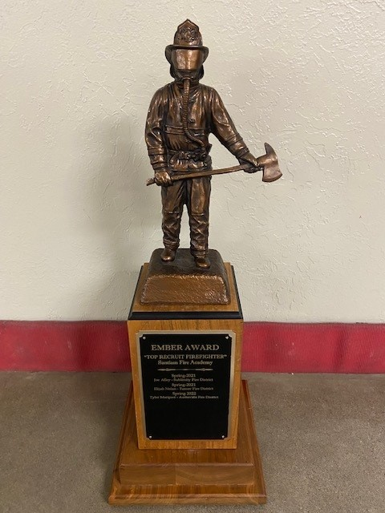
2022 Ember Award Recipient Tyler Marquez

Services & Equipment Provided
ARFPD provides fire protection and emergency services to the City of Aumsville and the surrounding rural fire district. The district serves a population of approximately 6,900 people out of two strategically located Fire Stations. The response area includes both suburban and rural environments. City and District areas alike are experiencing small growth in housing and commercial/industrial construction.

The ARFPD is an all-hazards response agency and handles fire suppression, emergency medical services, hazardous materials response, fire prevention, fire safety education, and health education on injury and illness prevention for our community.

The district operates two Type 1 fire engines, two Type 1 water tenders, two Type 1/Type 3 brush trucks, three light duty rescues, and one command unit out of the two stations. A combination of career and volunteer personnel staff a single command unit within the district 24/7.

Apparatus | Year | Make/Model | Location
Command 65 | 2016 | Ford Explorer | Aumsville Station 650
Rescue 66 | 2016 | Ford Explorer | Aumsville Station 650
Rescue 67 | 2008 | Ford F-350 | Shaw Station 670
Brush 65 | 2016 | Rosenbauer Timberwolf | Aumsville Station 650
Brush 67 | 2016 | Rosenbauer Timberwolf | Shaw Station 670
Engine 65 | 2016 | Pierce Impel | Aumsville Station 650
Engine 66 | 2016 | Pierce Impel | Aumsville Station 650
Tender 65 | 2002 | KME FL112 | Aumsville Station 650
Tender 67 | 2002 | KME FL112 | Shaw Station 670
Utility 65 | 2020 | Ford F-150 | Aumsville Station 650

Personnel Services
ARFPD depends on a combination of volunteers and paid staff to respond to emergency calls. The volunteers are dedicated, service-oriented people who reside or work within the district boundaries and are willing to go through an extensive training program to serve as a member of the ARFPD. The district has seen an increase in out-of-district volunteers, only 38% of the firefighters in January 2023 were in-district.

The combination of volunteer and career personnel include the Fire Chief, Training Captain, Office Administrator, seven part-time firefighters and 29 volunteers including firefighters, EMS personnel, tender drivers, cadets, and the District Link Support Team. Paid staff make up only 26% of all personnel.
Paid Personnel | Actual  2019-20 | Actual  2020-21 | Actual  2021-22 | Budget  2022-23 | Proposed  2023-24
Fire Chief | 0.53 | .53 | .53 | .53 | .50
Training Captain | 1.00 | 1.00 | 1.00 | 1.00 | 1.00
Maintenance | 1.00 | 1.00 | 1.00 | 1.00 | 0
Office Administrator | 1.00 | 1.00 | 1.00 | 1.00 | 1.00
Part-Time Firefighter | 1.59 | 1.59 | 1.59 | 1.77 | 2.60
 | 5.12 | 5.12 | 5.12 | 5.30 | 5.10

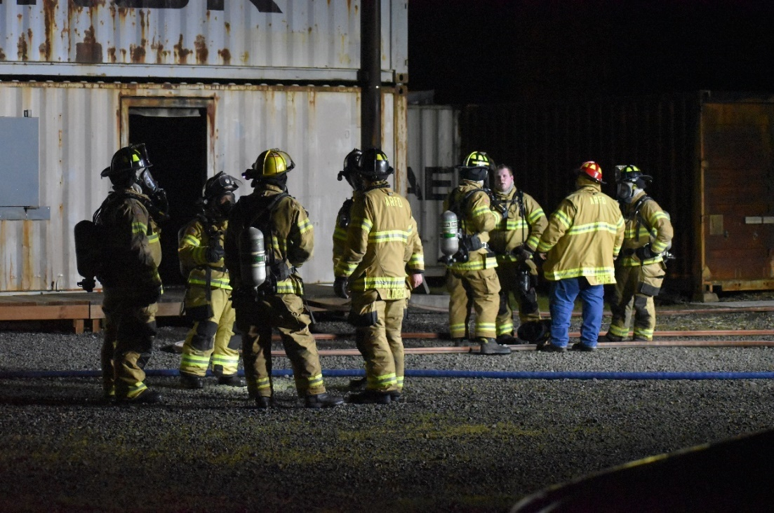
Night Drill

Organizational Chart
Aumsville Board of Directors

Fire Chief
(Executive Officer)

Officers
Part -time Staff
Cadet Program
Volunteer Firefighters
Tender Driver Program
District Link Support
Aumsville Station
650
490 Church Street
Shaw Station
670
5604 Shaw Hwy SE
Training Captain
Office Administrator

Budget Message

Citizens of the District, Honorable Board Members, and Members of the Budget Committee.
The Proposed 2023-2024 Budget is hereby proposed for your review.

The Aumsville Rural Fire Protection District ends FY 22-23 in sound financial condition. Our annual audits are consistently without findings and demonstrate solid fiscal policy. District Administrative Staff and Directors reviewed and adopted several updated fiscal policies in the past year. We are currently updating our Strategic Plan which includes references to district finances and the development of a 5-year financial plan, an apparatus replacement schedule, a major equipment replacement schedule, and a facility plan. In addition, objective measures are being developed for each of the strategic components along with quantified measures.
The 2023-24 budget is the tool that will drive the Fire District operations for the coming year. As a Special District organized under Oregon Revised Statue 478, the District is subject to the tax limitation measures passed by voters over the past decade, and as such, finds itself in a position where expenses necessary to maintain services will soon exceed resources. The District is in the final three years of a ten-year General Obligation Bond that paid for the apparatus and equipment bought in 2016.
Fortunately for the citizens of the District, as well as the entire State, 2022 saw a significant reduction in wildfire response compared to previous years. The District, as part of the State Mobilization Plan, has historically deployed resources to large fires anywhere in the State as well as Washington and California. With the record precipitation totals this spring, we anticipate a reduction this year as well.
There are no significant changes or major capital purchases proposed for the coming fiscal year. The Board of Directors has tabled plans for an upgrade to the fire station due to the threat of recession and will revisit regularly as this upgrade is sorely needed.
Like most rural fire districts, the ARFPD is in desperate need of volunteers. To counter that need, the District currently utilizes a combination of local home responders, out of district volunteers, sleepers, and part-time employees and two career responders to provide services. This combination works well and allows us to maintain critical services at minimal cost.
We are confident that we have proposed a budget adequate to fund District Operations for the coming year.
Sincerely,
Roy Hari, Fire Chief

Strategic Planning

Planning Process
The Aumsville Rural Fire Protection District (ARFPD) Strategic Plan was developed in 2015 by a working group of 15 people, which consisted of board of directors, staff, volunteer firefighters, support team members, community members, business owners, and a neighboring district fire chief. The Fire Chief and Assistant Chief visited with many business owners, community members and volunteers. All were encouraged to attend and participate in a two-day process. Administration brought these folks together and gave them information about who ARFPD is, and the services provided. The budget and plans for the future of the district were presented. At the time of this meeting, the district did not have a formal plan in place.

Work on the strategic plan to redevelop started in March of 2023 utilizing eight people that consisted of the board of directors and staff. The process is being facilitated by Special Districts of Oregon (SDAO). ARFPD staff presented an overview of the district, existing plan accomplishments, and concerns for the future. The process has to date occurred over two work sessions and included SWOT analysis where the district’s Strengths(S), Weaknesses (W), areas of Opportunity (O), and potential Threats (T) were identified. The purpose of the SWOT analysis was to provide an open and honest assessment of an organization’s positive and negative aspects. It also served as a benchmarking tool for evaluation of the district’s success in achieving stated goals and objectives. The next step will be to add measurements and annual goals to achieve those measurements.

Evaluating performance according to those benchmarks is one of the final stages of the strategic planning process. In fact, the plan is only useful so long as it achieves the desired results. The only way to know if those results are being achieved is through periodic examinations and performance measurements.

Strategic plans are typically thought of as living documents where the planning process is never actually finished but becomes subject to revisions as circumstances change and new challenges emerge. Review of the ARFPD Strategic Plan will be ongoing and occur formally at least every five years.
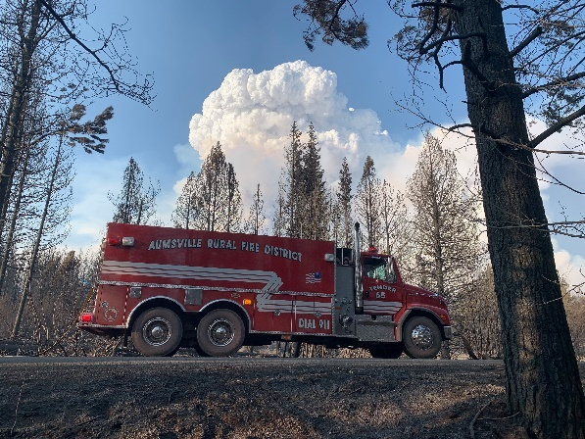

Challenges
Through surveys and discussions at the planning meeting of the SWOC analysis, administration identified key internal and external challenges currently facing the ARFPD. Acknowledging these challenges and developing ways to manage them is one of the many benefits of going through the strategic planning process.
Continual employee and volunteer involvement with engagement can be a challenge in a small organization. Personnel expressed a desire to be more involved and empowered to help make decisions. They also expressed the need for better communication between all levels of the organization as well as a recognition program.
Leadership and officer development training is important in achieving ARFPD’s mission. Currently, the District has a limited training program in place to develop leadership capabilities. Compounding the issue, 90% of the Officers have retired or moved on, which has left the district unprepared for the next generation of leaders. This represents a significant loss of key experienced and skilled leaders to help train our next generation. In order for ARFPD to improve and continue its service delivery, we must develop quality leaders and empower them to make good decisions. As our world changes and the services, we provide evolve, we must find a better way to adapt and overcome.

A critical component of ensuring a skilled and safe emergency work force is job specific training. The district provides a broad range of emergency and non-emergent services. Delivering all the necessary training for services provided, which state law and industry standards require, is a challenge for a small district with a limited budget.
Many government agencies have experienced the effects of the economic downturn. There is a 24/7 need for emergency services but fewer dollars to accomplish that growing need. The district needs to find ways to maximize existing resources and continue to work within its existing budget. Coordination with partner agencies and expanding these partnerships becomes even more important during difficult budget times.

Investments in modern fire and building codes, as well as an emphasis on fire prevention, have changed the landscape of firefighting. Currently, 53.27% percent of the district’s calls are for emergency medical services (EMS). These are calls that range from a cold to cardiac arrest. Within these EMS calls there has been an explosion of non-emergent calls. A non-emergent call is defined as a patient who does not exhibit an injury or illness that requests medical care, a false fire alarm, or an emergency incident that is cancelled. 32.51% percent of the ARFPD’s total number of yearly responses are currently non-emergent. This means valuable emergency resources are being utilized for non-emergent needs, and in turn, may impact the ability to respond to real emergencies.

ARFPD also faces the challenge of keeping the equipment and facilities updated to meet ongoing federal and state standards. The district will never have the financial ability to maintain these two items within our yearly budget until the population or business community grows substantially. By implementing long range goals, as well as quality purchases, there will be fewer times the public will be asked to assist in maintaining these items.

Aumsville’s population is not only growing, but it is also becoming more diverse. As we see our neighborhoods grow there are inevitable changes within the culture of the city. The ARFPD must adjust to these unique and changing needs within each of these different cultures. Providing quality service to everyone becomes even more important. Personnel will continue to overcome cultural and language barriers, which are especially challenging during high-pressure emergency situations.

Mission, Vision, and Values
All ARFPD personnel are guided by the mission, vision, and values. The mission is the core purpose for why the ARFPD exists. The vision is the description for where the district strives to be in the future; it should inspire and motivate. Values are the guiding principles for the organization. These are the essential enduring beliefs. Planning participants reviewed these, and some minor revisions were made.
The current Mission statement is:
“To protect life, property and environment of our community.”
The current Vision is:
“Regional leaders for fire prevention, emergency response, and community involvement; with an on-going commitment to professionalism.”
The current Values:
The desire to serve, the courage to act and the ability to perform.
The ability to anticipate, influence and adapt to change.
Be effective and efficient in the service we provide to our community and region.

Strategic Plan Framework
The ARFPD’s Strategic Plan revolves around four goal areas. Each goal is supported by and accomplished through a series of high-level strategies and more specific action steps. In the context of this strategic plan, goals are defined as overarching visionary statements that guide the future direction of the district. The strategies listed beneath each goal outline a plan of action for achieving that goal. Below each strategy is a set of action steps which are tasks that are concrete and specific. These steps are designed to help implement the strategy and ultimately reach the stated goal.
The parameters used by the work group in the development of the goals, strategies and actions were as follows:
- Aligned with the district mission, vision, and values - the four stated goals must line up with and move the organization forward in fulfilling its mission, vision, and values.
- Achievable - current economic realities dictate that the goals be practical and focused, so they can be accomplished within the district’s current budget.
- Built on consensus - shared agreement among the district’s key stakeholders, which include employee, leadership, labor, and the board on what is important to the district’s future.
- Measurable - each goal area along with the accompanying strategies and action steps must be measurable, so it is possible to objectively determine whether the goal is being achieved.
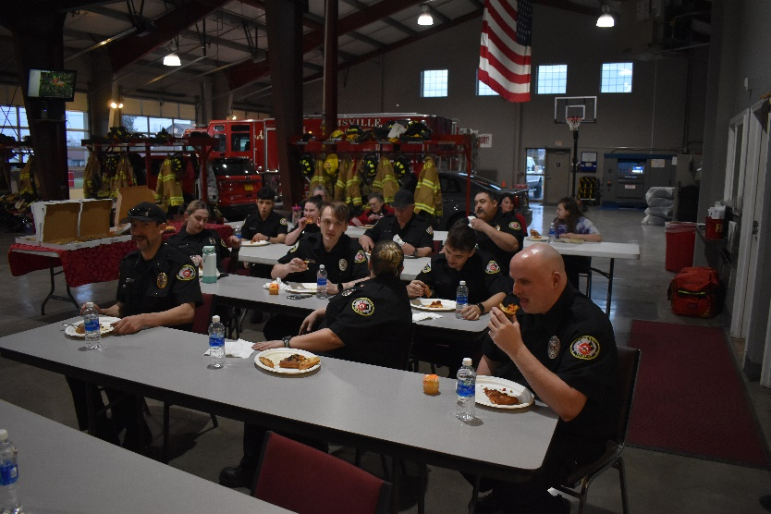
Due to the intentionally ambitious nature of the plan, the goals and strategies may need to be accomplished in phases over a period of time. The goals and strategies will be reevaluated periodically to keep the plan relevant and current. As the external and internal environment in which the district operates is in constant flux, this plan should remain a living document for the district’s future.

Goal 1: Human Resources
This goal is to develop the leadership abilities of the district personnel.

Strategy 1: Incorporate leadership training throughout all levels of the organization.
Action Steps:
- Develop and implement leadership training relevant to the chief, company officers, and firefighters with measurable outcomes and defined expectations.
- Develop leadership training for all district personnel with measurable outcomes and defined expectations.
Strategy 2: Promote personal accountability, growth, and development; and promote the meeting of workplace expectations for all personnel.
Action Steps:
- Provide on-going personnel management training for supervisors.
- Design a voluntary mentorship program.
- Provide accountability through performance evaluations that encourage improvement.
- Create a positive and progressive organization to encourage longevity among employees and volunteers.
- Encourage all personnel to improve and broaden their skills and expectations.
- Create programs built on time frames to help personnel become proficient and confident.
Strategy 3: Shared Resources are becoming more prevalent in today’s society.
Action Steps:
- Find ways to share management level employees.
- Find ways to drop boundaries and respond region wide instead of area wide.
- Create shared engine companies, share volunteers, and share services.
Strategy 4: Improved communication between employees, volunteers, and board members.
Action Steps:
- Develop a district newsletter, hold more staff meetings, and communicate at drills, officer meetings, and committee meetings.
- Send out emails at the end of each week and produce calendars with events.

Goal 2: Service Delivery & Demand
This goal is to ensure the district provides the best service possible, drop boundaries when necessary, and be leaders in our region.
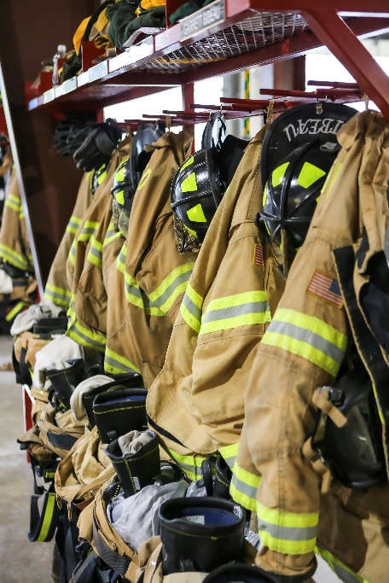
Strategy 1: Determine if the EMS Services we provide are appropriate for our community.
Action Steps:
- Cutting services for BLS calls and providing only a response to ALS calls.
- Charging for services within the new health care program.
- Develop response plans for ALS and BLS calls.
Strategy 2: Standards of response time; urban vs rural.
Action Steps:
- Develop a response plan for the call types.
- Establish a sleeper program.
- Add more paid positions whether they are part-time or full-time.
Strategy 3: Continue to work with the City of Aumsville to improve water supply.
Action Steps:
- Install adapters on the current hydrants for Storz fittings.
- Work with the City to improve the water storage system.
- Map the ponds and ditches that are an available water supply source for the rural community.

Goal 3: Financial Support
This goal was established to evaluate any means of cost recovery plans for the future and consider shared resources to support our Mission, Vision, and Values.
Strategy 1: Research finance avenues that encompass not only the goals we set forth in our strategic plan, but also our apparatus replacement, facility improvements, etc.
Action Steps:
- Be responsible and effective with the annual budget process.
- Communicate the need for bonds or tax levies thoroughly and properly within the community.
- Utilization of purchasing groups to lower the cost of purchased goods and services.
- Continued development of agreements with local businesses, industry, state, and the emergency services realm.
- More in-depth group purchasing amongst regional districts.
- Cost recovery for services rendered to out-of-district people.
- Establish a donation process, establish foundations, and hold fundraisers.
- Create separate plans; one for apparatus replacement, a second for equipment replacement, and a third for facility replacement.
- Improve transparency within the district through public events and regular presentations.

Goal 4: Community Outreach
This goal is designed to help the district stay abreast of cultures in the community, communicate plans, needs, and goals with the community.

Strategy 1: ARFPD needs to find ways to communicate to the public how the district operates and the financial plan.
Action Steps:
- Utilize the strategic plan so the community members know where the district is headed and the plan to get there.
- Publish the Mission, Vision, and Values on the website, Facebook, and in the stations.
Strategy 2: Publish and disseminate the emergency plan for natural disasters within the community.
Action Steps:
- Publish the disaster plan.
- Educate the community on the disaster plan, hold trainings, and get the community involved.
Strategy 3: Social Media usage
Action Steps:
- Improve the Facebook page.
- Improve and keep the website up to date.
- Possibly add a district twitter account.
- Utilize the local media outlets more frequently to improve this relationship.
Strategy 4: School outreach program and communicating the need for these programs.
Action Steps:
- Consider continued interaction with the school district administration.
- Ask for and provide a constant feedback loop to improve future interactions with students and faculty.
Strategy 5: Develop redundant communication tools in case of major system failures from natural disasters.
Action Steps:
- Backup system at the fire station.
- Utilize Hamm radio group as backup in emergency cases or natural disasters.
- Research other communication avenues within the community in the event of a failure.
- Publish and disseminate all aspects of the plan to everyone within the district.

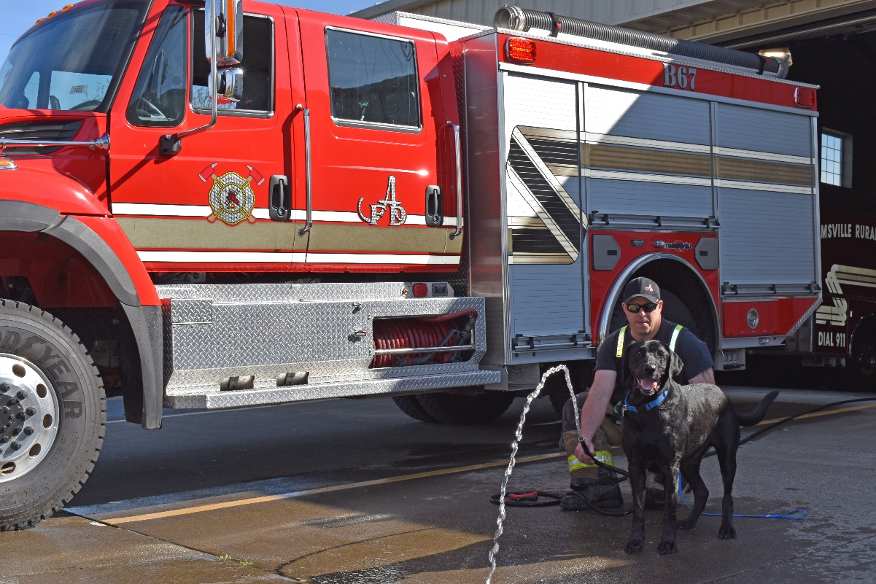

Budget Summary

Budget Process
In Oregon, local budget laws require rural fire protection districts such as ARFPD to create a proposed budget that includes estimates of expenditures and revenues for either a single fiscal year or biennium. Aumsville Rural Fire utilizes a single fiscal year budget. The proposed budget is presented to the Budget Committee. After the Budget Committee approves the budget, it moves to the hearing and adoption process which are noted on the tables throughout this document. A more detailed description of the process can be found in the Summary of Steps.
This process allows the district to establish a budget for controlling expenditures and a justification for imposing property taxes. Oregon Local Budget Law under ORS 294.305 to 294.565 sets out several specific procedures that must be followed.

Budget Calendar
EVENT | DATE | RESPONSIBILITY
Adopt 2023-24 Budget Calendar | January 12, 2023 | Board of Directors
Appoint budget officer | February 16, 2023 | Board of Directors
Appoint budget committee (BC) | February 16, 2023 | Board of Directors
Attend local budget law training | See Posted Schedule | Everyone
Prepare proposed budget | February – March | Budget Officer/Staff
Publish 1st notice of BC meeting (30 days) | April 11, 2023 | Staff
Publish 2nd notice of BC meeting (10 days) | No later than May 1, 2023 | Staff
BC meeting & subsequent meetings, if needed. | May 11, 2023 | Budget Committee
Publish notice of budget hearing | No later than May 31, 2023 | Staff
Hold budget hearing | June 8, 2023 | Board of Directors
Enact resolutions to adopt, etc. | June 8, 2023 | Board of Directors
Submit tax certification documents | By July 15, 2023 | Staff
Send copy of all budget documents to county clerk | By September 30, 2023 | Staff

Summary of Steps
- Develop the budget calendar. This becomes the simplified plan on the budget process.
- Appoint the Budget Officer. Each local government must have a budget officer. The Board of Directors appoints the budget officer and is under their supervision.
- Prepare the proposed budget. The budget officer supervises the office administrator who is responsible for preparing the budget for presentation to the budget committee.
- Budget Committee Meeting notice is published. As soon as the proposed budget and budget message are ready, the office administrator publishes a “Notice of Budget Committee Meeting.” The first notice is published in the Statesman Journal newspaper, and the second notice is published on the Aumsville Rural Fire’s website.
- Budget Committee meets. The Budget Committee meets to hear the budget message, receive the budget document, and hear the public. All budget discussions occur at this meeting. Additional meetings are scheduled if needed.
- Budget Committee approves the budget. Once the budget committee is satisfied with the proposed budget, making any additions, deletions, or modifications, it is approved. The budget committee must approve an amount or rate of total ad valorem property taxes to be certified and sent to the county assessor.
- Budget Summary and notice of budget hearing published. The approved budget will then go before a budget hearing, which must be held by the board of directors. Notice of the budget hearing is published in the Statesman Journal five to 30 days prior to the hearing. In addition, the budget summary and notice of hearing are published on the district’s website.
- Budget hearing held. The budget hearing is held to receive citizen testimony on the budget approved by the budget committee. The hearing is open to the public and available on-line.
- Budget adopted, appropriations made, tax levy declared and categorized. After listening to public comments at the hearing, the board of directors enacts a resolution to formally adopt the budget, make appropriations, and levy and categorize any tax before June 30th.
- Budget filed and levy certified. Two copies of notice of levy and the categorization certification and two copies of the budget resolution are submitted to the Marion County Assessor’s office before July 15th. A copy of the complete budget gets sent to the county clerk before September 30th.

Budgeting, Accounting and Financial Reporting Method
The financial statements of ARFPD have been prepared on the modified cash basis of accounting. The accounting and financial reporting treatment is determined by the applicable measurement focus and basis of accounting. Measurement focus indicates the type of resources being measured such as current financial resources or economic resources. The basis of accounting indicates the timing of transactions or events for recognition in the financial statements.

Brush 65 at Willamette National Forest at the Cedar Creek Fire in 2022

The government-wide financial statements are reported using the economic resources measurement focus within the limitations of the modified cash basis of accounting, as described below.

Governmental fund financial statements are reported using the current financial resources measurement focus. The Fire District’s budget is prepared and adopted for each fund on a modified accrual basis of accounting in the main program categories required by Oregon Budget Law.

The district uses the following major governmental funds:
General Fund – The General Fund is the district’s primary operating fund. It accounts for all financial resources of the district, except for those required to be accounted for in another fund. The primary source of revenue is property taxes. Expenditures are primarily for fire suppression, emergency services, administrative support, and other operating costs.

Debt Service Fund – The Debt Service Fund accounts for the general servicing of the district’s long-term debt. The primary source of revenue is property taxes. Expenditures are primarily for principal and interest payments on long-term debt.

Equipment Reserve Fund – The Equipment Reserve Fund accounts for the accumulation of funds for the specific purpose of replacing equipment. The primary source of revenue is transfers from other funds. Primary expenditures are capital outlay.

The district uses the following nonmajor governmental funds:
Apparatus Reserve Fund – The Apparatus Reserve Fund accounts for the accumulation of funds for the specific purpose of replacing apparatus. The primary source of revenue is transfers from other funds. Primary expenditures are capital outlay.

Facility Fund – The facility fund accounts for the accumulation of funds for the specific purpose of replacing buildings. The primary source of revenue is transfers from other funds. Primary expenditures are for capital outlay.

Revenues
Revenues are based upon several sources with the majority being property taxes.
- Recurring revenues will consist of current and prior year’s taxes for Aumsville Rural Fire Protection District.
- The Assessed Value (AV) increased per Marion County Assessor’s office Summary of Tax Roll between 2021 and 2022 was 5.07%. For 2023-24 budgeting purposes, revenues will be built on a 3% increase in Taxes Estimated to be Received from the FY 2022-23 Budget.
- The tax collection rate remains at 96% based on historical analysis.
- Contract income from the Maintenance Program has been reduced from the previous fiscal year of $5,000 to an estimated $500 in revenue will be received from neighboring districts purchasing Diesel Exhaust Fluid (DEF) which is purchased in bulk.
- Interest income estimates are increasing based on the current rate of 3.10%.
- Conflagration receipts have been increased by 2/3 due to the number of available trained volunteers.

Expenditures
Personnel Services
Personnel Services is the largest expense in the proposed budget, making up 52.9% of the General Fund and includes 6.5 Full-Time Equivalent (FTE) employees.

- Public Employees Retirement System (PERS) rates will increase at:
- Tier 1/ 2 Fire rate = 31.06%
- Oregon Public Service Retirement Plan (OPSRP) Fire rate = 25.75%
  - OPSRP Fire totals 76.9% of all District employees
- Tier 1/ 2 General Services rate = 22.98%
- Health insurance premiums are increasing 5.65%
- CPI West is currently at 6.0% and for Urban Wage Earners and Clerical Workers it’s 5.7%; however, the district is proposing an 8% CPI increase for full-time staff.
- Two new FTE positions are proposed through a grant opportunity.
Materials and Services
- Materials and Services costs for all funds are estimated to be $312,250 compared to $316,852 in FY2022-23, an increase of 1.7% overall. The main cause of this increase is due to the increase in prices such as fuel.
Capital Outlay, Construction and Purchases
- No major Capital Outlay expenditures are planned. However, we are budgeting for at least one set of turnouts and minor building repairs.
- The district is planning to spend approximately $25,000 out of the Property & Facilities fund as the building increases with age, and the repairs increase as well.
Transfers
Transfers will be made in the following funds:
- Apparatus Fund 4 will receive $10,045.
- Equipment Fund 6 will receive $25,000 to help with future turnout purchases.
- Facility & Property Fund 7 will receive $13,600 to help with future construction projects to include a new addition and remodel.
Debt Service
Rural Fire Protection Districts formed under ORS Chapter 478 are limited in the total amount of general obligation bonds, together with liabilities outstanding incurred under rental or lease purchase agreements. At no time may their aggregate amount exceed one and one-fourth percent (1.25%) of the Real Market Value of taxable property in the District. The calculation of the District’s debt capacity is as follows:

General Obligation Debt Capacity
Real Market Value (Fiscal Year 2022-23) | $1,369,960,783
Debt Capacity
Capacity (1.25% of Real Market Value) | $ 17,124,509
Less: Outstanding Debt Subject to Limit | (944,446)
Remaining Capacity | $ 16,180,063
Percent of Capacity Issued | 5.51%

The following table presents information regarding the District’s direct debt, including the bonds, and the estimated portion of the debt of overlapping taxing districts allocated to the District’s property owners.

Debt Ratios
Real Market Value (Fiscal Year 2022-23) | $1,369,960,783
Estimated Population | 7020
Per Capita Real Market Value | $195,151
Debt Information | Gross Debt |  | Net Debt
District Debt | $ 944,446 |  | $ 944,446
Overlapping Debt | 10,200,124 |  | 10,200,124
Total Debt | $11,144,570 |  | $11,144,570
Bonded Debt Ratios
District Debt to Real Market Value |  |  | 0.10%
Total Debt to Real Market Value |  |  | 1.23%

The debt service reflected for FY2023-24 includes both the Series 2015 General Obligation Bond and the Series 2019 Full Faith and Credit Bond. The General Obligation Bond has no rating and issues into Fund 2 Debt Service Fund. The total General Obligation bond debt service requirements are met through the collection of property taxes and will total $267,400 in FY2023-24.

The Series 2019 Full Faith and Credit Bond is for the purchase of the 145 N 4th Street property. It is not rated and is paid from the General Fund. The payment for the Series 2019 for FY2023-24 will total $22,176.

Minimum Fund Balance Policy
The Fire District’s adopted Fund Balance Reporting policy has a stated goal that the Board of Directors maintain a prudent level of financial resources to protect against the need to reduce service levels. The district requires a reserve consisting of unassigned amounts equal to not less than four months of General Fund operating expenditures or 24% of General Fund expenditures and other financing uses. For the General Fund, analysis indicates that the baseline amount for “sufficient resources” has been approximately 25% of operating. With the combination of the Unappropriated Ending Balance and Operating Contingency Reserves, the District has budgeted $331,273 in General Funds.

Future generation of firefighter

 | Aumsville Rural Fire Protection District
 | 3-year Budget Summary - All Funds
 |  | FY2021-22 | FY2022-23 | FY2023-24
 |  | Actuals | Adopted | Proposed
RESOURCES
Beginning Fund Balance |  | $702,950 | $778,550 | $819,220
Revenues
 | Tax Revenues | $1,050,044 | $974,782 | $1,080,026
 | Interest | $4,242 | $5,000 | $15,000
 | Sale of Assets | $0 | $500 | $500
 | Grants | $46,470 | $23,000 | $25,000
 | Other Revenues | $217,027 | $18,000 | $43,100
Total Revenues |  | $1,321,245 | $1,021,282 | $1,163,626
Transfers In |  | $40,000 | $5,000 | $48,645
TOTAL RESOURCES |  | $2,064,195 | $1,804,832 | $2,031,491
REQUIREMENTS
Expenditures
 | Personnel Services | $646,030 | $647,410 | $819,910
 | Materials and Services | $261,986 | $316,852 | $312,250
 | Capital Outlay | $48,703 | $64,000 | $44,000
Non-Allocated:
 | Debt Service | $276,594 | $283,300 | $291,400
 | Contingency |  | $50,000 | $41,273
 | Transfers Out | $40,000 | $5,000 | $48,645
 | Ending Fund Balance | $790,882 | $438,270 | $474,013
TOTAL EXPENDITURES |  | $2,064,195 | $1,804,832 | $2,031,491
TOTAL REQUIREMENTS |  | $2,064,195 | $1,804,832 | $2,031,491

 |  | Aumsville Rural Fire Protection District
 |  | FY2023-24 Budget Overview - All Funds
 |  | Proposed
 | General | Debt Service | Apparatus | Equipment | Property & Facilities | Total
RESOURCES
Beginning Fund Balance | 658,352 | 16,116 | 51,955 | 19,241 | 73,556 | 819,220
Revenues
Tax Revenues | 807,626 | 272,400 | ─ | ─ | ─ | 1,080,026
Interest | 15,000 | ─ | ─ | ─ | ─ | 15,000
Sale of Assets | 500 | ─ | ─ | ─ | ─ | 500
Grants | 25,000 | ─ | ─ | ─ | ─ | 25,000
Other Revenues | 43,100 | ─ | ─ | ─ | ─ | 43,100
Total Revenues | 891,226 | 272,400 | ─ | ─ | ─ | 1,163,626
Transfers from other funds | ─ | ─ | 10,045 | 25,000 | 13,600 | 48,645
TOTAL RESOURCES | 1,549,578 | 288,516 | 62,000 | 44,241 | 87,156 | 2,031,491
REQUIREMENTS
Expenditures
Personnel Services | 819,910 | ─ | ─ | ─ | ─ | 819,910
Materials & Services | 310,750 | ─ | ─ | 1,500 | ─ | 312,250
Capital Outlay | 15,000 | ─ | ─ | 4,000 | 25,000 | 44,000
Total Expenditures | 1,145,660 | ─ | ─ | 5,500 | 25,000 | 1,176,160
Debt Service | 24,000 | 267,400 | ─ | ─ | ─ | 291,400
Contingency | 41,273 | ─ | ─ | ─ | ─ | 41,273
Transfers Out | 48,645 | ─ | ─ | ─ | ─ | 48,645
 |  |  |  |  |  | 0
Ending Fund Balance | 290,000 | 21,116 | 62,000 | 38,741 | 62,156 | 474,013
TOTAL REQUIREMENTS | 1,549,578 | 288,516 | 62,000 | 44,241 | 87,156 | 2,031,491

Schedule of Appropriations
 |  | General | Debt Service | Apparatus | Equipment | Property & Facilities | Total
Personnel Services | 819,910 |  | ─ | ─ | ─ | ─ | 819,910
Materials & Services | 310,750 |  | ─ | ─ | 1,500 | ─ | 312,250
Capital Outlay | 15,000 |  | ─ | ─ | 4,000 | 25,000 | 44,000
Transfers to Other Funds | 48,645 |  | ─ | ─ | ─ | ─ | 48,645
Contingency | 41,273 |  | ─ | ─ | ─ | ─ | 41,273
Debt Service | 24,000 |  | 267,400 | ─ | ─ | ─ | 291,400
Total Appropriations | 1,259,578 |  | 267,400 | ─ | 5,500 | 25,000 | 1,557,478
Unapprop. Ending Fund Balance | 290,000 |  | 21,116 | 62,000 | 38,741 | 62,156 | 474,013
Total adopted Budget | 1,549,578 |  | 288,516 | 62,000 | 44,241 | 87,156 | 2,031,491

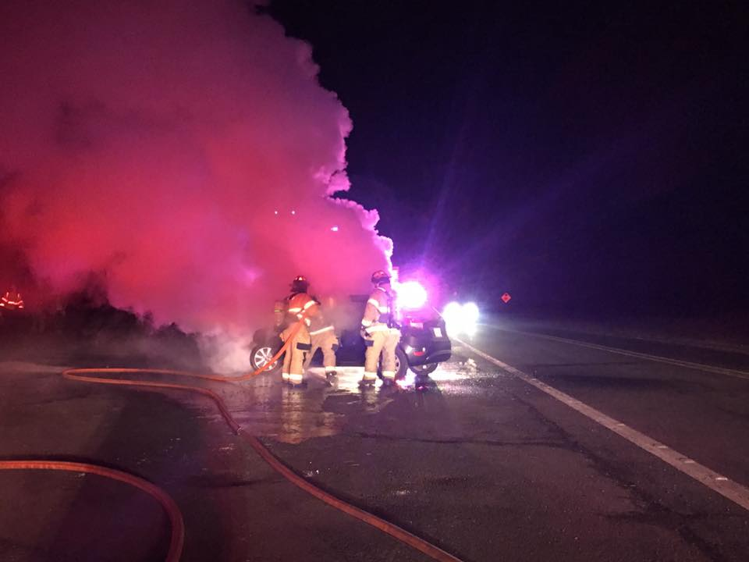

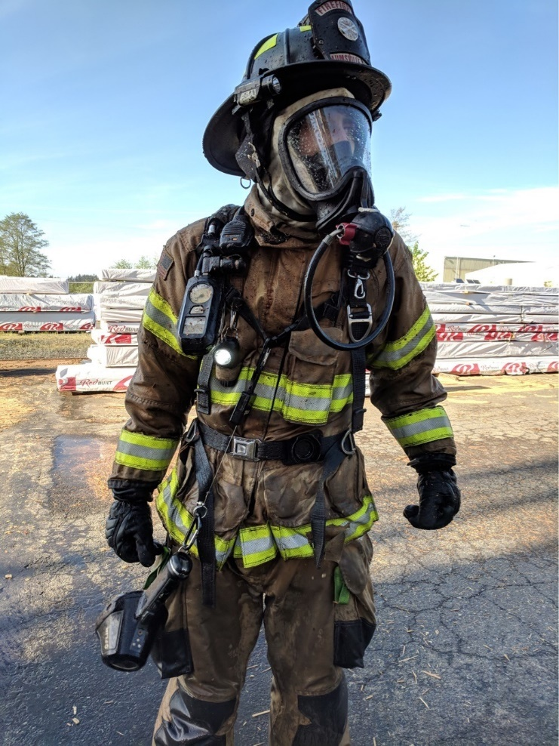

Resources

Key sources of funds for the ARFPD are property taxes, grants, and donations/fundraisers. Conflagration receipts are not sources of income but reimbursements for fighting fires. Analysis of all the resources occurs to identify trends that might be useful in determining the estimates for the current budget year. Some of the resources are required by law to be tracked separately.

FUND | REVENUES
Fund 1 - General Fund | Property Taxes  Grants  Donations/Fundraisers
Fund 2 – Bond Debt Fund | Property Taxes
Fund 4 – Apparatus Fund | General Funds  Surplus Apparatus Sales
Fund 6 – Equipment Fund | General Funds  Surplus Equipment Sales
Fund 7 – Property & Facilities Fund | General Funds  Sale of Surplus Property

Below are the graphs by revenue source used in preparing the FY2023-24 Proposed Budget:

Property Taxes
The charts above indicate that the district relies upon property tax collections to provide services. ARFPD has a permanent tax rate of 1.3612 per $1000 of Assessed Value (AV) for operating expenses and is planning an additional $281,474 for bonded debt service. This would be approximately 1.3616 per $1000 of AV. As soon as the expenditures and non-property tax revenues (i.e., interest earned) for the upcoming fiscal year are determined, the tax levy will be certified by the county assessor, which is based on the permanent tax rate and the total assessed value of the district.

The district assumes a 3% growth on the assessed value of property. The AV to the Measure 5 adjusted Real Market Value (RMV) ratio in ARFPD is minuscule. The median listing home price in Aumsville, OR is $498,900, and has been trending down -7.2% year-over-year. The Median home sold price was $554,500.

Property taxes comprise of 90.63% of total revenues for the FY2023-24 proposed budget. Since FY2018-19, the district has experienced an average annual tax revenue increase of approximately 16.73%. Based on growth and historical trends, the district has budgeted a 3% increase in tax collected in the current year revenues.

Beginning Fund Balance
In order for the district to have enough funding for the fiscal year requirements until the levied taxes are received, the board of directors have created a Minimum Fund Balance for the General Fund policy. The purpose of this policy is to ensure that 24% of General Fund expenditures or 4 months of General Fund operating expenditures are reserved for use during July 1 through November 15. This amount along with any unexpended funds becomes the ensuing year’s Beginning Fund Balance. The calculated amount for the FY2022-23 year was $290,000; the district estimates it will begin the FY2023-24 with $658,352. The staff has researched the financial needs of the district and has projected that reserving $290,000 will be enough to sufficiently fund the operations of the District from July 1 to November 15.

Grant Revenue
The district seeks and applies for grants on a regular basis. The funds are used for special projects and capital purchases. In FY2022-23, the district received wildland grant funds of $35,000 to hire part-time wildland firefighters during the height of wildland fires. The district is planning on applying for the grant in FY2023-24 as well as a Oregon Fire Service Capacity grant for two full-time personnel.

Other Revenue Sources
Contracted Services
ARFPD provided services to multiple other fire districts and the City of Aumsville through intergovernmental agreements (IGA) for service. The services that were provided for fleet maintenance ended in FY2022-23 when the Maintenance position vacated. The district will no longer continue the program.

Cost Recovery
The district contracts with EF Recovery to collect on vehicle accidents from nonresidents all materials and services provided. The district is estimating this to bring in an additional $1500 in revenues.

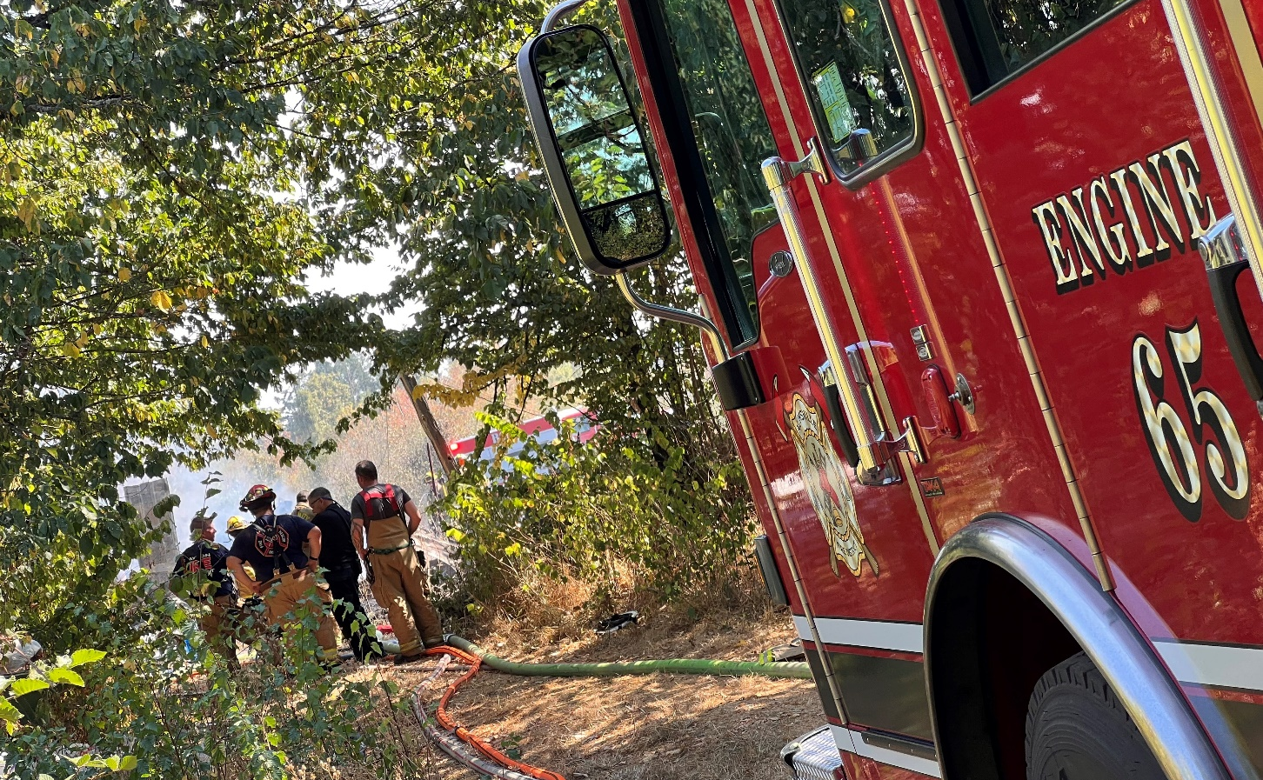
2022 Fire on Albus Road

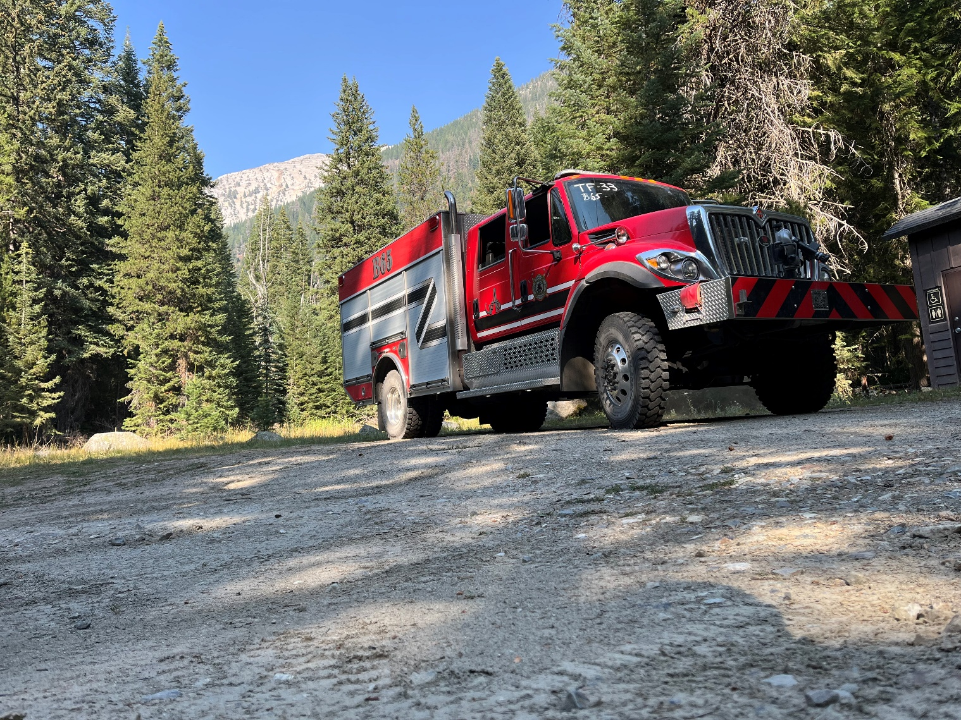
Sturgill Fire in 2022: Wallowa Whitman National Forest

Requirements

As the ARFPD continues to grow and develop, the district will require additional personnel and equipment to serve the community. The largest expenditure that the ARFPD will continue to experience is labor costs, and this will remain due to the district being a service organization. Additionally, aging, and inadequate fire stations and apparatus must be strategically replaced to meet the organizational needs of the ARFPD. The district continues to work on long-range financial plans along with a capital plan.

General Fund – Fund 1
The General Fund is ARFPD’s primary operating fund, and it accounts for everything that is not required to be accounted for in a separate fund. The primary source of revenue for the district is the collection of property taxes. The district resources in the General Fund are allocated to the everyday operations of the district. Appropriations for the expenditures occur at the following levels for the General Fund: Personnel Services, Materials and Services, Capital Outlay, Debt Service, Interfund Transfers, Contingency and Unappropriated Ending Balance.

General Fund Resources

Beginning Fund Balance
The beginning fund balance for FY2023-24 reflects per Board policy the reserved funds from FY2022-23 plus any unspent funds. The carried forward funds are estimated to be $658,352 for FY2023-24.
Property Taxes
The ARFPD’s main source of Revenue in the General Fund is property taxes, which comprises 91.85% of the General Fund’s operating revenues. Marion County’s Assessed Value data shows a 5% change in growth from FY2020-21 to FY2021-22. Estimates from Marion County indicate a 4% growth for the district. However, based on experience, the staff has included a conservative increase of 3% in the property tax revenues. The collection rate for FY2020-21 for Marion County increased to 95.5%. As Marion County increased the collection rate the previous levied tax estimated to be received will decrease due to the better collection rate in the year taxed.
Sale of Assets
In prior years, the district has sold employee turnouts to Fire Departments who pick up the part-time employees for full-time employment. This occurs mainly for two reasons, the first being the employee is hard to size and the second is that turnouts take 6 months or longer to receive. The district had this occurring in FY2022-23. The district also sold some tools when the Maintenance Program was discontinued. There are no plans to sell any assets in FY2023-24.
Conflagration Receipts
The Board of Directors have set a policy to pay volunteers within 30 days of their return, which is prior to the district being reimbursed from the state. Therefore, the District includes revenue and expenditures for conflagrations. Due to the increased number of mobilizations the district participates in, the district has increased the revenue for conflagration receipts to $30,000.
Cost Recovery
ARFPD has contracted with EF Recovery to collect on Motor Vehicle Accidents (MVA) and Fires when the incident occurs to people who do not reside in the district. The purpose is to recover funds for services that belong to residents of the district. In FY2020-21 the district realized a 157.99% increase in funds and FY2021-22 is currently showing a decrease of 71.67%. The district has recovered $384 in FY2022-23. Until the process stabilizes, the district will continue to budget the same dollar amounts.
Grant Proceeds
The district will continue to apply for both federal, state, and local grants such as the SDAO Safety grant. In FY2021-22, the district was awarded an Oregon State Fire Marshal (OSFM) Wildfire Season Staffing grant of $35,000 which was expended in FY 2022-23. The district was able to hire four part-time staff during the peak fire season. In FY2022-23, the district also received the OSFM iPad grant for three iPads; a 50/50 safety grant to add security cameras at the Shaw station (received funds totaling $1922); and an Oregon Department of Public Safety Standards and Training grant for training shelters (received funds totaling $2329.50).
For FY 2022-23 The district has applied for several grants. The Oregon Fire Service Capacity Program through the OSFM for two full-time firefighter positions. This is a matching grant to be utilized over a three-year period. The district applied for the OSFM Community Wildfire Risk Reduction Grant on a joint application with Marion County Fire District #1 and Keizer Fire. This project will help protect people, property, and communities from wildfire through risk reduction programs, such as community cleanup days.

Maintenance Program
The Fleet Maintenance Program was discontinued in FY 2022-23 when the Mechanic vacated the position. With the decline in revenues, in FY2020-21 the ARFPD realized a 35.53% decrease in revenue, FY2021-22 saw a 90.13% decrease in revenue, and FY2022-23 is seeing a 69.04% in decreased revenues. The district reduced the Maintenance Program income to $500 for FY2023-24 due to bulk purchases of Diesel Exhaust Fluid (DEF) and firefighting foam. The neighboring districts still purchase these items from ARFPD and see bulk price savings.

General Fund Expenditures
The total expenditures for FY2023-24 in the General Fund are $1,155,660. This is an increase of 15.36% over the prior year’s adopted budget before the adjustment for conflagrations. This increase is due to the non-allocated personnel services of $212,446, which is being reserved if awarded the Oregon Fire Service Capacity Program grant.

Personnel Services
Allocated Personnel Services will see a decrease in FY2023-24 by 6.17% or $39,946. This is due to the Maintenance Officer vacating his position. The bulk of these funds were placed in Personnel Services Not Allocated while the district waits for grant award notification.
The major changes in Personnel Services include a salary for a part-time Chief, an 8% CPI increase, a 5% increase in medical insurance rates, and a little over 5% increase in PERs rates.

Materials and Services
This category reflects a decrease of $4,602 or 1.46%. Due to the new financial management software, the budget is being reorganized on the LB-30 and is reflected in the Materials and Services category.

Capital Outlay
Capital Outlay in the General Fund includes small equipment purchases and station improvements.

Debt Service
In 2019, ARFPD purchased property utilizing a Full Faith and Credit Bond which is not rated. The district will have the bond paid in 2028. The district will make a principal and interest payment of $24,000.

Below is a summary of projected debt service requirements for the series 2019 Full Faith and Credit Bond:
Fiscal | The Bonds |  | Total
Year | Principal | Interest | Debt Service
2024 | 19,000 | 3,176 | 22,176
2025 | 20,000 | 2,692 | 22,692
2026 | 20,000 | 2,032 | 22,032
2027 | 20,000 | 1,956 | 21,956
2028 | 17,000 | 1,524 | 18,524
 | $96,000 | $11,380 | $107,380

Ending Fund Balance and Operating Contingency
Operating Contingency were calculated consistent with prior years. Reserves are set at $41,273 which is approximately one month’s expenditure or 2.7% of the budget. These funds are to be used for any unforeseen emergencies.
The Ending Fund Balance per Board policy must be equal to but not less than four months of the General Fund operating expenditures or 24% of the General Fund Expenditures. In FY 2023-24, the district is maintaining the reserved amount of 5.8 months of the General Fund operating expenditures. The district continues to grow the reserved amount toward 24% of General Fund Expenditures.

Fund Summary

Debt Service Fund 2
The Debt Service Fund receives revenues from property tax collections and expends those funds solely on interest and principal payments for the General Obligation debt used to fund capital acquisition, 2 Rosenbauer Timberwolf Brush Trucks and 2 Pierce Impel Engines. The 2015 General Obligation bond is not rated. For the FY2023-24 proposed budget, debt service payments include the Series 2015 principal and interest.
Below is a summary of projected debt service requirements for the 2015 GO Bond:
Fiscal | The Bonds |  | Total
Year | Principal | Interest | Debt Service
2024 | 245,000 | 22,400 | 267,400
2025 | 260,000 | 12,600 | 272,600
2026 | 55,000 | 1,100 | 56,100
 | $560,000 | $36,100 | $596,100

Apparatus Fund 4
The Apparatus Fund is used to plan for replacement or major repairs of large capital items. The main revenue sources for this fund include transfers from the General Fund, conflagration receipts, and sales of surplus vehicles. ARFPD expends these funds to replace capital items on replacement schedules, including apparatus, station vehicles, and tires.

There are no purchases planned for FY2023-24.

Equipment Fund 6
The Equipment Fund is used to plan for the replacement of large capital items. The main revenue sources for this fund include transfers from the General Fund and conflagration receipts. ARFPD expends these funds to replace capital items on replacement schedules, including self-contained breathing apparatus (SCBA), turnouts, saws, and communication radios.

Capital purchases planned for FY2023-24 include:
- Purchase of a set of turnouts
- Unforeseen equipment maintenance such as saw chains.

Property & Facilities Fund 7
The Property & Facilities fund receives is used to plan for land acquisition, non-bond funded capital construction and facility improvements. The main revenue source for this fund includes transfers from the General Fund. Funds are expended for capital leases, purchases, construction, and repairs of district buildings.

For the FY2023-24 proposed budget, staff recommend the appropriation of $25,000 of the fund balance to allow budgetary flexibility for any repairs of the current fire stations. The current project of a building addition and remodel is contingent upon the district receiving grants and bonds and does not have a set begin date. However, if bonds and grants are received these funds will be utilized for the new construction. I.e., a temporary building for offices, land prep, etc.

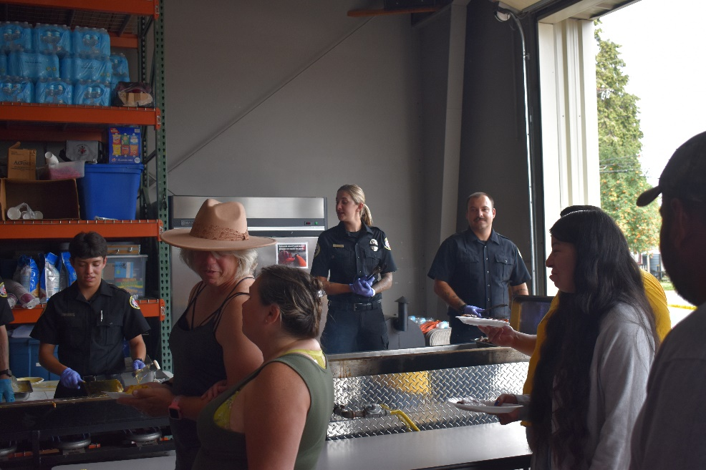

2022 Corn Festival Breakfast

Accounting Policies and Procedures

Introduction

Division of Duties
The following is a list of personnel who have responsibilities within the fiscal department:
Board of Directors
- Appoint Budget Officer.
- Approve Budget Calendar.
- Reviews and approves all financial reports.
- Reviews and adopts annual budget.
- Adopts resolution for interfund loans.
- Adopts resolution for budget reallocations.
- Adopts resolution for budget contingency transfer.
- Reviews accounts payable check register monthly.
- Provides the first signature on all checks.
- Reviews and approves all purchases of goods, services and construction projects exceeding $10,000.00.
- Monitors district finances and the budget, setting policy or taking action to ensure the fiscal integrity of the organization.
Budget Committee
- Reviews and approves the annual budget.
Fire Chief
- Serves as the Budget Officer.
- Reviews and approves all financial reports.
- With input from the volunteers and staff, helps to develop the budget with the Office Administrator.
- Reviews accounts payable registers weekly.
- Reviews and approves purchases up to $10,000.
- Provides second signature on all checks.
- Reviews and approves all visa purchases and expenditures including payroll.
- Reviews and approves all fund transfers from the LGIP account to general checking.
- Reviews all deposits.
- Approves and releases all payroll ACH.
Office Administrator
- Develops Budget Calendar.
- Oversees all accounting and financial functions of the district.
- Prepares all financial reports.
- Prepares general journal entries as required.
- Reviews Trial Balance Reports for accurate Fund allocation.
- Develops the annual budget with input from the Chief, volunteers, and staff.
- Directs audit preparation activities and provides support.
- Provides oversight for purchasing guidelines.
- Reconciles and processes all accounts payable.
- Verifies compliance with purchasing policy.
- Maintains W-9 files on required vendors.
- Runs accounts payable checks weekly in conformance with payable dates.
- Transfers required funds from the LGIP account to general checking.
- Reports check registers to Board of Directors and Fire Chief.
- Files 1099s and W2s at calendar year end.
- Receives checks, copies, prepares deposits and ensures delivery to the bank.
- Prepares and sends out all accounts receivable invoices for fleet maintenance program.
- Reconciles all bank accounts.
- Runs Fund reports each month for the Board of Directors and Fire Chief.
- Maintains accounting work paper files.
- Prepares payroll monthly.
- Posts payroll to bank’s ACH system.
- Maintains employee files and payroll records.
- Processes payments to all retirement accounts including the electronic PERS System.
- Process annual workers compensation reports and audit.

Cash Receipts Procedures
Cash receipts are made up of property tax turnovers, interest income, fleet maintenance income, and miscellaneous income that comes in throughout the year.
Money is received either by mail or in-person at the District Office. The Fire Chief, Office Administrator or designee will open all US Mail for processing. The volunteers and paid staff receive cash receipts in-person at the district reception desk, giving the customer a receipt for any cash payments or if requested by customer a receipt is given for checks received. If there is actual currency/coin received, a receipt is written. A three-part receipt book is used, one copy is given to the customer, one part is attached to the cash receipts for posting, and the other is kept in the receipt book for tracking and control purposes. All cash receipts are then sent to the business office for processing that will be taken to the bank by staff or courier service for deposit. The money is locked up until deposits are couriered to the bank. All bank deposits are taken to the bank on a weekly basis. The completed deposit, which includes a deposit summary, all documentation, copies of receipts, and copies of checks are reviewed and then filed in the current fiscal year Account Receivable (AR) files.

LGIP Transfers
Bank transfers are done periodically each quarter based on keeping funds in the district general checking account to cover weekly Accounts Payable (AP) batch runs and the monthly payroll processing. The Office Administrator makes the bank transfers and posts to the accounting software. All transfers are documented and reviewed with signature by the Fire Chief and then filed in the current fiscal year AR files.

Monthly AR Posting
Each month before bank statements is reconciled, all AR posting is completed for all, transfers, tax turnovers to LGIP (automatic), and EFT payments to the district accounts (with review by the Fire Chief). Tax turnovers are deposited by the county directly into our LGIP account each month. An AR checklist is completed each month with the reconciliation and each reconciliation process by the Office Administrator is reviewed with the Fire Chief and copies of all reconciliations are sent to a Board member for review as well. All documentation is filed in the AR files and Bank Statement files for the corresponding fiscal year.

Cash Disbursement Procedures
Accounts Payable (AP) is prepared weekly. Mail is opened by the Fire Chief or his designee and couriered to the business office for processing. All open invoices are then matched to open packing/shipping receipts, documentation and submitted for approval for payment by the Office Administrator. All invoices are then coded for expense and a new batch with an AP processing checklist is ready for posting into AP in the accounting software by staff. Any invoices that are in question are reviewed with the person who ordered the item and the Fire Chief before processing for payment continues.

An AP aging detail summary with general ledger account codes is then printed by the Office Administrator or designee and the report along with the invoices and processing sheet, the AP batch, are then reviewed by the Fire Chief for any changes in coding, discrepancies with invoices, and verification of approval for non-recurring invoices. The Fire Chief will then sign off on the AP processing sheet and reports and returns it to the business office staff to complete any changes. Final reports and checks are then run by the Office Administrator or designee. Checks and invoices are then given to the Fire Chief for a final review and signature as well as a Board member. The Office Administrator or designee then process the checks for mailing to vendors; the check stubs are then attached to each invoice and the invoices are filed in the current fiscal year AP files. The final reports and completed processing sheets are then filed in the current fiscal year AP files.

Petty Cash
Petty cash is used for district expenses as necessary such as conflagrations and rehab expenses on scene that are not possible to wait for a regular AP check cycle. The petty cash fund shall never exceed $500.00. Petty cash request forms are completed for personnel requesting reimbursement or cash advance for district expenses. The completed form is then given to a supervisor for authorization. When the purchase or expense is completed, the receipt and any change is returned to the district office, receipt is coded for budget purposes, tape is run to verify balance, the transaction is then saved in a file to be reconciled each month by the Office Administrator, Fire Chief or designee during the monthly AR Bank Account reconciliations or as needed. Final review of reconciled account is done by the Fire Chief and paperwork is filed appropriately in the district AP files.

Reconciliations
The Office Administrator reconciles the bank accounts each month, printing the reconciliation report and filing it in the file for the current fiscal year only after the Fire Chief reviews and signs as well. A copy of the reconciliation report is emailed to a Board member for review each month. The Office Administrator has the bank reconciliations and bank registers readily available for review at request.

The following occurs during the reconciliation process each month:
- A comparison of dates and amounts of daily deposits as shown on the statements.
- Comparison of bank transfers to be certain both sides of the transactions are recorded on the books.
- Investigation of items rejected by the bank.
- A comparison of canceled checks with the disbursement journal as to check number, payee, and amount.
- An accounting for the sequence of checks both from month to month and within a month.
- An examination of canceled checks for authorized signatures, irregular endorsements, and alterations.
- A review of voided checks for proper defacement.
- Investigate checks which have been outstanding for more than three months.

Purchases
The district purchasing policy provides a process for documenting approval guidelines and authorization levels for staff in making purchases.

- The product will be analyzed for availability, competitive pricing, product quality, delivery, and installation and/or service factors when considering available vendor sources.
- Review district’s operating budgets to determine if item is budgeted and to determine remaining budget availability for the related expense accounts.
- If an employee or volunteer is considering the purchase of an item or service that is not budgeted or, if remaining unencumbered budget funds are insufficient, employee will obtain purchase approval prior to initiating the purchase process. This approval will be obtained from the Fire Chief through the use of the district’s purchase order form.
- Purchase approval on budgeted items and non-budgeted items:
  - The Fire Chief is authorized to exercise all authority, power, and duties of the contracting agency up to a maximum of $10,000 for budgeted procurements and $2500 for unbudgeted items. The district Board exercises sole spending authority for procurements over these limits. All procurement procedures are governed by the district’s Public Contracting Rules.
  - Unless otherwise specified by motion of the Board, the Fire Chief holds authority to sign all procurements and other written financial obligations of the district in amounts within the Fire Chief’s spending authority, established above. Unless otherwise specified by motion of the District Board, and upon board approval of the procurement, the Fire Chief shall sign obligations in amounts greater than the Chief’s spending authority.
Purchase Documentation
- When a purchase decision is initiated, an employee will prepare a district purchase order form for approval by the Fire Chief. This documentation will be provided to the Office Administrator for reconciliation to the item’s invoice.
- The employee responsible for the purchase will approve the invoice prior to issuance of a vendor’s payment. The approving employee will date and initial the invoice and confirm the correct expenditure amount and budget account code for the charge.
- The Fire Chief will review and approve normal on-going budgeted operating invoices such as utility, postage, or storage bills.
- Employees will follow the district’s purchasing practices when procuring goods and services with the district’s visa card. When ordering goods by telephone or on the internet an employee will obtain a receipt to document the purchase. In the event a receipt cannot be obtained, the employee will provide a written statement, approved by the Fire Chief, to the Office Administrator. This documentation is required by the Office Administrator to reconcile the monthly bankcard statements and to allocate charges to the appropriate expense accounts. In addition, credit card users will note the purpose of the expenditure on the receipt submitted to the Office Administrator. Employees will ensure the expenditures do not exceed the credit limit on their card to prevent additional bank charges. No private purchases will be made on the district’s credit card without prior approval. Private reimbursements will be made directly to the bankcard company and given to the Office Administrator for processing with the district’s payment.

Payroll
Timesheets
The district has monthly pay periods. Electronic timesheets are completed by each employee and signed by their supervisor for approval. All timesheets are then sent to the Office Administrator prior to the last week of the month. Payroll is processed by the last day of the month. Timesheets are reviewed for accuracy before processing.

Payroll change form
Any payroll change forms are also reviewed and posted to the CenterPoint payroll system. This includes voluntary changes to direct deposit, 457 contributions, and W4 forms. Posted payroll changes are stamped entered, dated, and initialed and filed in the employee’s payroll file. All payroll changes processed each pay period are included for review in the final payroll packet before filed.

Payroll processing
Timesheet data are auto entered into the CenterPoint payroll system. The payroll system auto calculates the payroll liabilities and wages based on the employee master file information. The Office Administrator reviews to make sure that all auto calculations are correct before finalizing the payroll. Payroll reports are run to verify hours and all liabilities are correct for the payroll cycle. Reports are then reviewed for accuracy and paystubs (direct deposit) and paychecks are run, matched to supporting documentation by each employee. Checks and paystubs are then reviewed for a final time and signed. Checks require two signatures, the Fire Chief or Training Captain and a Board member. Direct deposit amounts are then entered into the bank management system for ACH by the Office Administrator. The amounts are verified by the Fire Chief and released. The Fire Chief reviews each payroll batch and signs the checklist as well as all reports and paperwork along with a Board member. All employees receive direct deposit at this time.

Payroll liabilities
Payroll liabilities for the pay cycle are auto generated through the CenterPoint payroll system. Not all liabilities are due each payroll cycle; some are paid only once a month and others are paid with each payroll cycle. Liabilities are reviewed for accuracy; reports are then run by each liability that is due and required to be paid with this pay cycle. Reports are reviewed and then hard checks, EFT or auto pays through ACH system are processed. Each liability has complete and accurate supporting documentation for filing in the paid files for each fiscal year. Payroll liabilities are paid from the district’s general checking account. Online web paid liabilities include the following:
- EFTPS – IRS (federal withholding, Social Security, and Medicare)
- DOR – Oregon state withholding, WBF (quarterly), State UI (Quarterly)
- ACH – PERS contributions
- ACH - ING 457
- HRA Veba – employer paid contributions each payroll period
Accountability
All transactions for each payroll cycle are documented and reviewed for accuracy and compliance. All supporting documentation for payroll and paid liabilities, each cycle is printed for review and required signature by the Fire Chief or his designee and a Board member. All of the documentation is then filed in the current year payroll files which are located in the district offices at ARFPD. They can be reviewed and are accessible by the Fire Chief and Board at any time.

Financial Reporting
The Office Administer prepares all the financial reports for the Chief and the Board of Directors. The Board of Directors receives a balance sheet, a budget to actual report for each fund, and a treasurer report that includes all account balances.
The monthly statements and financial reports are reviewed by the Fire Chief prior to distribution to the Board members. All reports are provided in the monthly Board packet.

Year-End Report/Audit
The district will conduct an annual audit in August of every year. District employees are to cooperate with all auditors, external and internal, regarding any records maintained for or by the district. All external and internal audit reports are to be sent to the Board of Directors and Fire Chief. The Fire Chief shall respond in writing to all external audit reports stating what actions have been taken to address the findings contained in the audit.
The Board of Directors, at their discretion, will solicit proposals from qualified firms of certified public accountants to audit the ARFPD’s financial statements, with the option of auditing the district’s financial statements for a designated number of fiscal years.

Fund Balance Reporting Policy (GASB54)

Stating the Process for Committing Funds
Commitment of fund balance shall be done through adoption of a resolution or ordinance by the Aumsville Rural Fire District Board of Directors. Further, commitments of fund balance may be modified or rescinded only through approval of the Aumsville Rural Fire District Board of Directors via resolution or ordinance.

Minimum Fund Balance for the General Fund
ARFPD is committed to maintaining a prudent level of financial resources to protect against the need to reduce service levels because of temporary revenue shortfalls or unpredicted one-time expenditures.
The ARFPD Minimum Fund Balance Policy requires a Reserve for Economic Uncertainties consisting of unassigned amounts equal to not less than four months of General Fund operating expenditures, or 24% of General Fund expenditures and other financing uses. If minimum balances fall below the required amount, every effort should be made to restore the fund balance in the upcoming budget cycle as is reasonably prudent under current conditions.

Granting Authorization for Specific Members of Management to Assign Fund Balances
The Office Administrator shall be responsible for monitoring and reporting the Aumsville Rural Fire District’s various reserves and fund balance categories. The Fire Chief is directed to make recommendations to the Board of Directors on the use of reserve funds both as an element of the annual operating budget submission and from time to time throughout the year as needs may arise. Annually, the Fire Chief or budget officer for the Aumsville Rural Fire District shall be responsible for identification of resource assignments within the proposed budget document. The assignments contained within the adopted budget shall be considered approved by the Board of Directors, and any changes in assignment shall be reported to the Board of Directors at each regular meeting.

Flow Assumption
When both restricted and unrestricted fund balances are available for use, it is the Aumsville Rural Fire District’s policy to use restricted fund balance first, then unrestricted fund balance. Furthermore, committed fund balances are reduced first, followed by assigned amounts, and then unassigned amounts when expenditures are incurred for purposes for which amounts in any of those unrestricted fund balance classifications can be used. Additionally, all spendable, unrestricted revenue amounts in debt service funds, and capital projects funds are committed to be used for the purpose for which the fund was established.

Financial Management Policy

Objectives
- Ensure that all financial systems, functions, and controls meet generally accepted auditing standards.
- Preserve capital through prudent banking and cash management activities.
- Achieve the most productive use of cash, minimize operating costs, and to control receipts and disbursements.
- Maintain competitive and good working relations with financial institutions.
- To provide safety to employees.

Banking Services
All District bank accounts must be authorized and approved by Board of Directors.
Banking services shall be solicited at least every five years on a competitive basis, and banks submitting proposals must meet the following minimum criteria:

- Verify that the bank you want to use is on the list of qualified depositories on the State Treasurer’s website http://www.oregon.gov/treasury/Divisions/Finance/LocalGov/Pages/Qualified-Depositories.aspx
- Be insured by the Federal Deposit Insurance Corporation
- Be able to facilitate transfers to and from the Local Government Investment Pool managed by the Oregon State Treasurer.
- Provide annual audited financial statements.

Check Signing
All five Directors shall be signers on District accounts. The Chief and one career officer shall also be singers on District accounts. The Board will specifically approve which career officer will be a signer. All checks require two signatures, one board member and one staff member. The Office Administrator will coordinate the notification of Directors when checks need to be signed. All signers on District accounts shall be bonded through the District’s insurance agent of record.

Checkbooks are to be in a secure place at all times during business hours and locked in a filing cabinet during non-business hours. The Office Administrator is responsible for maintaining a current signature card with the appropriate financial institution.

Checks for Accounts Payable will be run at least every other week. Board members will alternate check-signing duties in any pattern that assures opportunities to see checks and purchase orders before they are paid.

All minor deviations (up to $5000) from the approved budget document shall have the approval of the Fire Chief. Any major deviation (over $5000) from the approved budget document shall have the approval of the Board of Directors.

Billing and Receipts
The District will invoice all vendors for amounts due on a current basis. An accounts receivable age schedule will be prepared and monitored to ensure amounts due to the District. Invoices are due within 30 days of the billing date. Interest of one- and one-half percent (1 ½%) per month will be charged on all balances over 30 days.

State Funds/State Grants
If the state agency/grantor is willing and it is feasible, funds will be received via the Local Government Investment Pool.

Cash Forecasting
Each fiscal year, the Fire Chief will prepare an annual general fund cash flow budget for the District for approval by the board of directors. Each month the cash flow statement will be adjusted to reflect the current month’s actual cash flow and revise the remaining estimated cash flow schedule.

Debt
If feasible, the District may enter into long-term lease obligations or issue bonds to finance capital acquisitions upon approval of the board of directors. Before issuing any debt, the District will consult with appropriate internal and/or external financial advisors and legal counsel.

All leases, as reported in the District’s annual financial report, will be limited as follows:

- Annual leases will be limited to the economic life of the equipment or facilities to be purchased, and in no case, shall be extended beyond 20 years or as otherwise authorized by Oregon Revised Statutes.
- Lease purchases of equipment and facilities will be limited to fit within the District’s stated mission, goal or government role.
All lease-purchase payments must be included in the originating department’s approved budget.

Audits/Auditors
The District will conduct an annual audit by August of every year. The District realizes that scheduling is dependent on Auditor’s schedule. District employees are to cooperate with all auditors, external and internal, regarding any records maintained for or by the District. All external and internal audit reports are to be sent to the Board of Directors and Fire Chief. The Fire Chief shall respond in writing to all external audit reports stating what actions have been taken to address the findings contained in the audit.

The Board of Directors, at their discretion, will solicit proposals from qualified firms of certified public accountants to audit the Aumsville Rural Fire District's financial statements, with the option of auditing the District’s financial statements for a designated number of fiscal years.

Internal Controls
Duties will be assigned to individuals in such a manner that no one individual can control all phases of collecting cash, recording cash, and processing transactions in a way that permits errors or omissions to go undetected.
- The Fire Chief is authorized to request from the Office Administrator financial reconciliations when deemed appropriate for review.

- Deposits should be received by a person other than the depositor of the funds to ensure that funds are placed in the proper District accounts.

- All accounting computer records must be kept secure. Persons authorized to edit or review the records must be given passwords which only enable them to access the system. More than one person should be trained on the system. Accounting records should be backed-up on a regular basis.

- The person that does the reconciliation of District accounts should not be the same person that writes the checks. If it is not possible to have separate functions, then the books must be reviewed regularly by the Fire Chief.

- The Fire Chief or Office Administrator shall authorize the purchase goods and services and to charge the purchase to the appropriate expense account.

- The staff purchasing the goods should verify the receipt before forwarding for payment.

- Cash transactions should always involve more than one individual to ensure that cash is properly recorded and deposited.

- Authorization for writing off bad debt shall be given to the Office Administrator, Fire Chief, and Board of Directors at the following levels:

- $0 to $100 Office Administrator or Accounts Receivable Officer
- $101 to $500 Fire Chief
- $500 and above Board of Directors

- Petty cash funds should require full documentation, including the purpose of the expenditure, expense account and who received the petty cash funds.
- More than one District employee or board member should be required to sign checks. ORS198.220 requires that any officer or employee of the District who is charged with the possession or control of District funds and properties be bonded or have an irrevocable letter of credit issued by a commercial bank.
- Online banking requires board approval and verification of all transactions by the Fire Chief or by a person who did not make the online banking transaction.
- Transfer of funds between banking accounts and state investment pool accounts will be verified by the Fire Chief or by a person who did not make the transfer.

Financial Responsibilities
- Bank Reconciliations: Shall be prepared by the Fire Chief. If this is not possible the bank reconciliations will be prepared by the Office Administrator and subject to spot reviews by the Fire Chief. The Chief shall initial and date bank reconciliations when reviewed.
- Accounts Payable: The Office Administrator will maintain a system to age accounts payable. Invoices will be analyzed to take advantage of any discounts available. Invoices will be tied to their respective purchase order and the receipt of goods will be verified before entry in the ledger for payment.
- Payment of Bills: Bills will be prepared for review, approval, signature and payment at least twice a month.
- Receivables: Deposits should be received by a person other than the depositor of the funds to ensure that funds are placed in the proper District accounts. Deposits will be recorded in the ledger and deposited when received by the Office Administrator. If this is not possible, the Chief shall review, initial and date the deposit.
- Payroll: The Office Administrator will prepare payroll on the last or second to the last business day of the current month for payment to occur on the first of the next month. Staff will submit their time sheet to their supervisor during the last business week of the current month. The Fire Chief will approve any adjustments in next month’s payroll. The Office Administrator will:
- Track payroll and benefits,
- Prepare monthly federal and state deposits,
- Prepare annual federal and state reports,
- Make PERS and Deferred Compensation payments,
- Track annual, sick, and personal leave,
- Prepare annual reconciliation reports.

Credit Card Use

Overview
District issued credit cards issued to an individual employee or volunteer are for the purpose of making authorized purchases for the benefit of the District within certain limits.
- Use of issued credit card is to: Promote efficiency in the procurement of goods and services for the District. Provide a convenient method for obtaining goods and services. Supplement purchase orders, check requests and travel requests in accordance with the purchasing policy, travel policy, budget limitations and all other policies. Pay for or reimburse personnel for District-approved business expenses.
- The procedures described in this policy are intended to: Minimize exposure to legal liability, due to inappropriate use of credit cards. Ensure appropriate internal controls are established and maintained. Ensure that goods and services are obtained in an ethical and competitive manner.
- Those eligible to be issued a credit card: Personnel with a legitimate need for an issued credit card on an ongoing or temporary basis as determined and approved by the fire chief.
- Those NOT eligible to be issued a credit card:
- Outside contractors/consultants.
- Employees on any type of extended leave of absence, including, but not limited to, FMLA, medical, disciplinary and any other leaves of absence.
- Employees whose privileges have been revoked due to abuse, misuse or other violations of this or other District policies and standards related to credit card use.
- When to use the card: Purchases can be made in person, over the telephone or using fax, mail or the Internet. Each cardholder is required to save detailed receipts of each transaction and submit those receipts to the Office Administrator as outlined in this policy. In addition, there is a maximum dollar amount established per month for each card, and that amount may not be exceeded. For necessary purchases that exceed the dollar limitations or are otherwise not permitted by this policy, current procedures for requisitions/purchase orders or personal services contracts must be used.
- Prior to using the card, cardholders must:
- Sign the Cardholder Agreement Form (See Appendix A) and return it to the Administrative Office
- Sign the back of the card

Card Usage
- Ethical Use: All personnel are considered public officials and are subject to the State Government Ethics requirements. Accordingly, all ARFPD personnel must refrain from any use of issued credit cards that:
- Creates an actual or potential conflict of interest.
- Results or potentially results in the appearance of using public office for personal financial gain or avoidance of financial detriment.
- Otherwise violates any provision of the Oregon Government Ethics statutes and rules.

If an employee or volunteer encounters a potential conflict of interest or potentially could be receiving personal financial gain or avoiding financial detriment, or if the employee/volunteer has any question regarding his/her obligations for the ethical and lawful use of a District credit card, he/she should either stop the transaction or contact the fire chief for guidance before completing the transaction. Alternatively, the individual may also submit a requisition to administration for purchase of requested items consistent with the requisition policies and procedures.

- Types of Services/Supplies: Details of purchasing are included in this manual, but a few key points are reiterated here. All purchases with a District-issued credit card must be for official business of the Aumsville Rural Fire Protection District.

- Typical Card Uses: Cards may generally be used for the following types of purchases. In all cases, personnel must also comply with all other applicable policies related to the purchase: (including but not limited to policies requiring advance written management approval, etc.)
- Meetings/Event Planning or Facilities
- Training Courses/Seminars
- Courier Services
- Postage
- Memberships, Dues, Subscriptions
- Catering
- Office Supplies
- Training & Reference Materials
- Meals as approved within policy
- Certain travel-related expenses
- Fuel as approved within policy
- Emergency scene rehab supplies
- Other professional services
- Approved Meals: District funds may only be used to pay for meals if the reason for the meal is to conduct official District business during the meal and only if it provides a particularly practical time or setting for the discussion. (For example, if a mealtime is the most convenient or only time that two (or more) individuals may be available to meet or a neutral meeting place such as a restaurant provides a better environment to have a particular discussion.) In these instances, District funds may be used because the meal serves a District purpose and is for the benefit of the District as a whole. Itemized receipts will be required, and an explanation of the purpose of the meal may also be required. Meals will not include any alcohol or any gratuities in excess of 15%. The purchase of meals for people other than District employees is generally discouraged but may be approved by a chief officer on a limited basis if it is consistent with District business purposes. Any personal benefit derived by individual District personnel from their participation in District- approved business meals is merely incidental and should not be construed as an improper personal benefit.

District funds for meals may also be authorized if a chief officer schedules a working meal or workshop involving District business where no meal break is provided. These meals are for the benefit of the employer.

- Approved Travel Expenses: Approved travel expenditures are subject to established policies and procedures and may include, but are not limited to the following:
- Airplane tickets
- Hotel/Motel
- Meals, excluding alcohol
- Registration fees
- Class materials
- Fuel for personal vehicle only when Pre-approved by Fire Chief
- Prohibited Purchase Actions:
Examples of prohibited card uses:
- Cash advances,
- Personal expenses of any kind,
- Gasoline for personal vehicles- (only exception is 5.f of this policy),
- Gift cards (except as approved in advance by the fire chief for District business),
- Alcoholic beverages,
- Entertainment.
- Prohibited Usage also Includes but is not limited to:
- Breaking a purchase into smaller amounts in order to avoid following established procurement procedures and guidelines,
- Rebate to card holder,
- Percentage off program,
- Frequent flyer program.

Procedures/Records
All personnel who have been issued a District card must ensure that all required steps are completed when placing an order.
- Ship orders:
Contact the supplier and place the approved order:
- Provide the supplier with the credit card number and expiration date.
- Have the supplier ship according to terms.
- Give the supplier your name, District name, telephone number and street address.
- Make sure this information is included on the shipping label.
- Request the supplier to enclose a copy of the credit card receipt and a copy of the sales slip with each shipment, to confirm pricing.
- Pick-Up Orders:
When orders must be picked up at the supplier’s place, make sure you present your card, sign the charge slip, and obtain a copy of the charge slip and the cash register or hand-written receipt.
- Obtain proper information:
You must submit an itemized receipt or invoice from the vendor/supplier every time you use the credit card. Collect it at the time of purchase, have it sent to you or print it from the Internet, as appropriate. This receipt or invoice must contain the following information:
- Vendor name and address
- Date of purchase
- Description of each item and the quantity
- Price per item/extended price per item
- Shipping/handling charges
- Total amount of the transaction

The cardholder is responsible for obtaining appropriate documentation of each transaction. In the extreme situation that supporting documentation cannot be obtained, you must provide a detailed written explanation to your supervisor for approval.

Potential Problems
- Suppliers that do not accept credit cards:
You may contact the administrative office for purchasing options.
- Returns:
Goods purchased through a procurement card may be returned for DIRECT REPLACEMENT or CREDIT ONLY. Cardholders may not accept a cash refund. You must keep the credit receipt and original receipt for the log and submit it to administration as outlined in this policy.
- Disputed charges:
All personnel issued cards must cooperate in the District’s efforts to verify and/or dispute any charges to the card. Should the need to dispute a charge occur, personnel will be required to provide specific documentation regarding the charge in question.

Additional Cardholder Responsibilities
It is the responsibility of any person using a District credit card to write the correct General Ledger Account number from which the funds will be spent and initial the receipt. The responsible person will forward the receipts to the Office Administrator for payment of the bill. To ensure timely payments of District obligations all credit card receipts will be presented to the District office:
- Within seven (7) days from date of use of card; or
- Within seven (7) days, after returning from out of district business.

- Card security:
It is the cardholder’s responsibility to keep the card secure. Personnel who have been issued Districts credit cards are strictly prohibited from sharing the card or card number with anyone else unless given express permission to do so by the fire chief. If another person gains unlawful access to the card or you have reason to believe that your card/card number has been compromised, contact your supervisor and the office administrator immediately to discuss the situation and determine the next course of action.
- Lost or stolen cards:
In the case of a lost or stolen card, you must contact the number on the card to report the card lost/stolen and notify your supervisor and the office administrator immediately.
- Closing your account:
You must turn your card over to your supervisor or the office administrator immediately when:
- Requested to do so by the District or District management,
- You terminate employment with the District,
- You are on any type of extended leave of absence, including, but not limited to:
  - Personal leaves
  - FMLA
  - Other medical disability
  - Disciplinary leave
  - Any other type of leave of absence
When closing your account for any reason, you must immediately submit the card with a final credit card expense report and all receipts/invoices to your supervisor for approval and submission to the office administrator.

Misuse
Misuse of the card, as determined in the sole discretion of the Aumsville Fire District, may result in the forfeiture of the card, legal action against the cardholder and/or card user, and disciplinary action up to and including the termination of the cardholder and/or card user.

The Aumsville Fire District has provided the following examples of types of conduct that it considers to be misuse of credit cards. This list, however, is not intended to be exhaustive. Therefore, if you have any questions about appropriate use of the card, please contact your supervisor or the office administrator before using the credit card.

- Personal purchases:
It is a cardholder violation to make ANY personal purchase with the credit card, regardless of whether the cardholder intended to pay the District back for the purchase. Anything that is not purchased for the sole use and ownership by the District for approved District business will be considered to be a personal purchase. Meals purchased for District-approved business purposes do not constitute an improper personal use (as long as the meal purchase complies with District policy).
- Cash or cash-type transactions:
A cash or cash type transaction made using the credit card is not permitted. Examples of illegal transactions are cash advances, cash in addition to purchase, travelers’ checks, money orders, gambling, ATM transactions, etc., or cash taken in lieu of a credit for the return or exchange of a purchase.
- Purchase of items prohibited by policy:
Purchases of items listed in the manual as prohibited, purchases that have not been approved in accordance with any other District policy, and purchases that violate any other provision of this policy (such as splitting purchases) are considered misuse of the credit card and in violation of this policy.
- Habitual late submission of transactions/continual receipt loss:
Failure to reconcile, complete, sign and submit the monthly credit card expense receipts and source documentation to the designated supervisor for approval by the required due date constitutes a misuse of the card. Also considered misuse would be failure to obtain or retain receipts, packing slips and all other source documents required to reconcile the cardholder’s monthly statement.

Purchasing Policy

Purpose
To provide a process for documenting approval guidelines and authorization levels for staff in making purchases. This procedure will provide an accurate method of tracking individual purchases, provide purchase approval documentation, assign accountability to individual employees, and improve staff’s awareness of the District’s financial position in relation to budgeted line items.

Procedure
- The Board of Directors shall act as the “Contract Review Board” in accordance with ORS 279A.055.
- All purchasing shall conform to regulations contained in the Public Contract Rules Policy as adopted by the District.
- Analyze product availability, competitive pricing, product quality, delivery, and installation and/or service factors when considering available vendor sources. Quotes will be obtained and recorded on all major purchases unless specified otherwise.
- Review District’s operating budgets to determine if item is budgeted and to determine remaining budget availability for the related expense account(s).
- All budgeted single item expenditures will be made within the following guidelines:
      - $1000 or less. Shall have the approval of the Office Administrator.
      - Over $1000 to $10,000. Shall have the approval of the Fire Chief or designee. The Board shall be notified of expenses between $5000 and $10,000 in the monthly Board packet. Public contracts under $5000 are not subject to competitive bidding requirements. The Fire Chief or designee shall make a reasonable effort to obtain competitive quotes in order to ensure the best value for the District.
      - Over $10,000 to 99,999. Shall have the approval of the Board of Directors prior to commitment. All requests for approval shall have a minimum of three (3) competitive quotes recorded on the appropriate form before expenditure is made.
      - $100,000 and above. Shall have formal sealed bids requested in accordance with ORS 279C.365 and the Public Contract Rules Policy adopted by the District.
- If an employee is considering the purchase of an item or service that is not budgeted or, if remaining unencumbered budget funds are insufficient, employee will obtain purchase approval prior to initiating the purchase process. This approval will be obtained from the Fire Chief through the use of the District’s purchase order form.
- Volunteers are required to use a purchase order for the purchase of all goods using District funds. Purchase order approval should be obtained from the Office Administrator or Fire Chief.
- Purchase approval on budgeted items & non-budgeted items:
The Fire Chief for Aumsville Rural Fire Protection District is hereby authorized to exercise all authority, power, and duties of the Contracting Agency as that term is defined in District Public Contracting Rule 137-046-0110(9) up to a maximum of $10,000 for budgeted procurements and $2,500 for unbudgeted items. The District Board exercises sole spending authority for procurements over these limits. All procurement procedures are governed by the District’s Public Contracting Rules.

Unless otherwise specified by motion of the District board, the Fire Chief holds authority to sign all procurements and other written financial obligations of the District in amounts within the Fire Chief’s spending authority, established above. Unless otherwise specified by motion of the District Board, and upon board approval of the procurement, the Fire Chief shall sign obligations in amounts greater than the chief’s spending authority.

For purchase over $2,500 please refer to the Public Contracting Binder

Documentation
- When a purchase decision is initiated, the employee will prepare a District purchase order form for approval by the Fire Chief. This documentation will be provided to the Office Administrator for reconciliation to the item’s invoice. Purchase orders must contain at a minimum:
- Vendor Name
- Date
- Quantity
- Item Name
- Price
- Budget Account Number
- Name of the employee who ordered the item(s) and who approved, or will approve, the invoice, and the Chief if the purchase price exceeds spending authority identified above.
- Invoice number, if known
- Ship to Address
- Delivery Date
- Terms
- The employee responsible for the purchase will approve the invoice prior to issuance of a vendor’s payment. The approving employee will date and initial the invoice and confirm the correct expenditure amount and budget account code for the charge.
- The Fire Chief will review and approve normal on-going budgeted operating invoices such as utility, postage, or storage bills.
- Employees will follow the District’s purchasing practices when procuring goods and services with the District’s Visa card. When ordering goods by telephone or on the internet an employee will obtain a receipt to document the purchase. In the event a receipt cannot be obtained, the employee will provide a written statement, approved by the Fire Chief, to the Office Administrator. This documentation is required by the Office Administrator to reconcile the monthly bankcard statements and to allocate charges to the appropriate expense account(s). In addition, credit card users will note the purpose of the expenditure on the receipt submitted to Office Administrator. Employees will ensure expenditures do not exceed the credit limit on their card to prevent additional bank charges to the District. No private purchase will be made on the District’s credit card without prior approval. Private reimbursements will be made directly to the bankcard company and given to the office administrator for processing with the District’s payment.
- When a purchase decision is initiated, the employee will prepare a District purchase order form for approval by the Fire Chief. This documentation will be provided to the Office Administrator for reconciliation to the item’s invoice.
- The employee responsible for the purchase will approve the invoice prior to issuance of a vendor’s payment. The approving employee will date and initial the invoice and confirm the correct expenditure amount and budget account code for the charge.

Capitalization of Fixed Assets

Purpose
The Board of Directors shall determine the definition of “Fixed Assets.” This is necessary for compliance with Government Accounting Standards Board (GASB) 34.

Definitions
- “Fixed Capital Asset” is any item which has an initial purchase price of not less than $5,000 and has a useful life of at least one year. If the item is donated, the fair market value of the item donated shall be used in lieu of the initial purchase price.
- “Non-Capital Asset” is any item less than $5,000.
- The cost of normal building repairs shall not be capitalized.
- An addition or improvement, unlike a repair, that either enhances a building’s functionality (effectiveness or efficiency), or extends a building’s expected useful life, shall be capitalized if it meets the $5000 criteria.

Depreciation Schedules
- The “Depreciable Life” for each fixed Capital asset shall be assigned according to the following classifications:
  - Buildings and Structures 50 years
  - Motorized Apparatus
Fire Engines/Ladder Trucks 30 years
Water Tenders 30 years
Heavy Rescue Units 30 years
Med Duty Emergency Response Units 20 years
Light Duty Emergency Response Units 18 years
Staff vehicles 10 years
  - Equipment, Furnishings and Tools
Shop Tools and Equipment 25 years
Heavy Furniture 20 years
General Use Emergency Equipment 15 years
Office Equipment 10 years

Listing of Inventory
All fixed capital assets shall be fully and accurately inventoried. All identified fixed assets shall be properly labeled or tagged. Items that are not practical to tag will still be inventoried and noted that no tag is installed. A listing of the inventoried capital assets shall be readily available and reviewed and updated annually.
Non-capital items with a purchase price of at least $500 shall also have an inventory tag attached.
The cost to improve existing buildings, such as an enlargement, must be capitalized. However, the cost of normal repairs must not be capitalized; repairs must be expensed. An addition or improvement, unlike a repair, either enhances a building’s functionality (effectiveness or efficiency), or it extends a building’s expected useful life.

Debt Management Policy
If feasible, the district may enter into long-term lease obligations or issue bonds to finance capital acquisitions upon approval of the Board of Directors. Before issuing any debt, the district will consult with appropriate internal and/or external financial advisors and legal counsel.
All leases, as reported in the district’s annual financial report, will be limited as follows:
- Annual leases will be limited to the economic life of the equipment or facilities to be purchased, and in no case, shall be extended beyond 20 years or as otherwise authorized by Oregon Revised Statutes.
- Lease purchases of equipment and facilities will be limited to fit within the district’s stated mission, goal or government role.
- All lease-purchase payments must be included in the originating department’s approved budget.

Investment Policy

Purpose
This policy applies to the investment of short-term operating funds and capital funds including bond proceeds and bond reserve funds. Investments of employees’ retirement funds, deferred compensation plans, and other funds are not covered by this policy.

General Objectives
The primary objectives, in priority order, of investment activities shall be safety, liquidity, and yield.
- Safety. Safety of principal is the foremost objective of the investment program. Investments shall be undertaken in a manner that seeks to ensure the preservation of capital in the overall portfolio. The objective will be to mitigate credit risk and interest rate risk.
  - Credit Risk. The Aumsville Rural Fire Protection District will minimize credit risk, the risk of loss due to the financial failure of the security issuer or backer, by:
    - Limiting exposure to poor credits and concentrating the investments in the safest types of securities.
    - Pre-qualifying the financial institutions, broker/dealers, intermediaries, and advisers with which the District will do business.
    - Diversifying the investment portfolio so that potential losses on individual securities will be minimized.
    - Actively monitoring the investment portfolio holdings for ratings changes, changing economic/market conditions, etc.
  - Interest Rate Risk. The Aumsville Rural Fire Protection District will minimize the risk that the market value of securities in the portfolio will fall due to changes in general interest rates, by:
    - Structuring the investment portfolio so that securities mature to meet cash requirements for ongoing operations, thereby avoiding the need to sell securities on the open market prior to maturity.
    - Investing operating funds primarily in shorter-term securities or short-term investment pools.
- Liquidity. The investment portfolio shall remain sufficiently liquid to meet all operating requirements that may be reasonably anticipated. This is accomplished by structuring the portfolio so that securities mature concurrent with cash needs to meet anticipated demands (static liquidity). Furthermore, since all possible cash demands cannot be anticipated, the portfolio should consist largely of securities with active secondary or resale markets (dynamic liquidity). A portion of the portfolio also may be placed in the Oregon Short-Term Fund (OSTF) which offers next-day liquidity for short-term funds.
3. Yield The investment portfolio shall be designed with the objective of attaining a market rate of return throughout budgetary and economic cycles, taking into account the investment risk constraints and liquidity needs. Return on investment is of secondary importance compared to the safety and liquidity objectives described above. The majority of the portfolio is limited to highly rated/low risk securities in anticipation of earning a fair return relative to the risk being assumed. Securities shall not be sold prior to maturity with the following exceptions:
      - A security with declining credit may be sold early to minimize loss of principal.
      - A security swap would improve the quality, yield, or target duration in the portfolio.
  - Liquidity needs of the portfolio require that the security be sold.

Standards of Care
- Prudence The standard of prudence to be used by investment officials shall be the "prudent person" standard and shall be applied in the context of managing an overall portfolio. Investment officers acting in accordance with written procedures and this investment policy and exercising due diligence shall be relieved of personal responsibility for an individual security's credit risk or market price changes, provided deviations from expectations are reported in a timely fashion and the liquidity and the sale of securities are carried out in accordance with the terms of this policy.
Investments shall be made with judgment and care, under circumstances then prevailing, which persons of prudence, discretion and intelligence exercise in the management of their own affairs, not for speculation, but for investment, considering the probable safety of their capital as well as the probable income to be derived.
- Ethics and Conflicts of Interest. Officers and employees involved in the investment process shall refrain from personal business activity that could conflict with the proper execution and management of the investment program, or that could impair their ability to make impartial decisions. Employees and investment officials shall disclose any material interests in financial institutions with which they conduct business. They shall further disclose any personal financial/investment positions that could be related to the performance of the investment portfolio. Employees, officers, and their families shall refrain from undertaking personal investment transactions with the same individual with whom business is conducted on behalf of the Aumsville Rural Fire. Officers and employees shall, at all times, comply with the State of Oregon Ethics Commission code of ethics set forth in ORS 244.

- Delegation of Authority. Authority to manage the investment program is granted to the Fire Chief or designee hereinafter referred to as investment officer and derived from the following: ORS 294.035 to 294.053, 294.125 to 294.145, and 294.810. Responsibility for the operation of the investment program is hereby delegated to the investment officer who shall act in accordance with established written procedures and internal controls for the operation of the investment program consistent with this investment policy. Procedures should include references for: safekeeping, delivery vs. payment, investment accounting, repurchase agreements, wire transfer agreements, and collateral/depository agreements. No person may engage in an investment transaction except as provided under the terms of this policy and the procedures established by the investment officer. The investment officer shall be responsible for all transactions undertaken and shall establish a system of controls to regulate the activities of subordinate officials.

Safekeeping and Custody
- Authorized Financial Dealers and Institutions A list will be maintained of financial institutions authorized to provide investment and safekeeping services. In addition, a list will also be maintained of approved security brokers/dealers selected by credit worthiness (e.g., a minimum capital requirement of $10,000,000 and at least five years of operation). These may include "primary" dealers or regional dealers that qualify under Securities and Exchange Commission (SEC) Rule 15C3-1 (uniform net capital rule).
All financial institutions and broker/dealers who desire to become qualified for investment transactions must supply the following, as appropriate:
      - Audited financial statements,
      - Proof of National Association of Securities Dealers (NASD) certification,
      - Proof of state registration,
      - Completed broker/dealer questionnaire,
      - Certification of having read and understood the Aumsville Rural Fire’s investment policy,
      - Certification of agreement to comply with Aumsville Rural Fire’s investment policy,
An annual review of the financial condition and registration of qualified financial institutions and broker/dealers will be conducted by the investment officer.
  - Internal Controls The investment officer is responsible for establishing and maintaining an adequate internal control structure designed to reasonably protect the assets of the Aumsville Rural Fire from loss, theft, or misuse. The concept of reasonable assurance recognizes that (1) the cost of a control should not exceed the benefits likely to be derived and (2) the valuation of costs and benefits requires estimates and judgments by management.
Accordingly, the investment officer shall establish a process for an annual independent review by an external auditor to assure compliance with policies and procedures. The internal controls shall address the following points:
      - Control of collusion,
      - Separation of transaction authority from accounting and record keeping,
      - Custodial safekeeping,
      - Avoidance of physical delivery of securities whenever possible and address control requirements for physical delivery where necessary,
      - Clear delegation of authority to subordinate staff members,
      - Written confirmation of transactions for investments and wire transfers,
      - Development of a wire transfer agreement with the lead bank and third-party custodian and implementation of the appropriate safeguards,
      - Compliance and oversight with investment parameters including diversification and maximum maturities.
- Delivery vs. Payment All trades where applicable will be executed by delivery vs. payment (DVP) to ensure that securities are deposited in an eligible financial institution prior to the release of funds.
- Safekeeping Securities will be held by a third-party custodian as evidenced by safekeeping receipts.
- Pooling of Funds Except for cash in certain restricted and special funds, the Aumsville Rural Fire Protection District will consolidate cash balances from all funds to maximize investment earnings. Investment income will be allocated to the various funds based on their respective participation and in accordance with generally accepted accounting principles.

Suitable and Authorized Investments
- Investment Types Consistent with the GFOA Policy Statement on State and Local Laws Concerning Investment Practices, the following investments will be permitted by this policy and ORS 294.035 and 294.810:
  - US Treasury securities and other lawfully issued general obligations of the United States
  - Oregon Short-Term Fund
- Collateralization All bank deposits, time deposits, certificates of deposit, and savings accounts, shall be held in qualified Oregon depositories in accordance with ORS Chapter 295. Such deposits are designated cash management tools and not investments under this policy or otherwise.
ORS 294.035 (11) requires repurchase agreement collateral to be limited in maturity to three years and priced according to percentages prescribed by written policy of the Oregon Investment Council or the Oregon Short-Term Fund Board. On March 12, 1996, the OSTF Board adopted the following margins:
- US Treasury Securities: 102%
- US Agency Discount and Coupon Securities: 102%
- Mortgage Backed and Other*: 103%
*Limited to those securities described in ORS 294.035(1)

Investment Parameters
- Diversification The investments shall be diversified by:
  - Limiting investments to avoid over-concentration in securities from a specific issuer or business sector (excluding U.S. Treasury securities),
  - Limiting investment in securities that have high credit risks,
  - Investing in securities with varying maturities, and
  - Continuously investing a portion of the portfolio in readily available funds such as the Oregon Short-Term Fund.
- Maximum Maturities To the extent possible, the Aumsville Rural Fire Protection District shall attempt to match its investments with anticipated future cash flow requirements. The maximum maturity shall be the anticipated use of the cash or 18 months, whichever is shorter, unless:
  - This investment policy has been submitted to the OSTF Board for comment prior to being approved by the Board of Directors and complies with the requirements of ORS 294.135. In this case, the maximum maturity shall be defined in policy.
  - The funds are being accumulated for a specific purpose, including future construction projects, and upon approval of the Board of Directors, the maximum maturity date matches the anticipated use of the funds (ORS 294.135(1)(b) and 294.135(3)).
If this investment policy has been submitted for review by the OSTF Board as specified above and in accordance with ORS 294.135(1)(a), debt service reserves may be invested to a maturity date not exceeding five years. Otherwise, debt service reserves shall not be invested to a maturity date exceeding one year.
- Maximum Percentages of Investments Surplus funds available for investment are those funds not required for immediate expenditure, and include: investments, savings accounts, CDs and OSTF deposits. Balances in checking accounts, negotiable order of withdrawal (NOW) accounts and demand deposit accounts are not considered surplus funds.
The maximum percentages for investments of surplus funds are as follows:
Security | Limitation | Maximum Maturity
US Treasury | None
OSTF Balances | None, except the maximum balance imposed by statute | N/A
Due to fluctuations in the aggregate surplus funds balance, maximum percentages for a particular issuer or investment type may be exceeded at a point in time subsequent to the purchase of a particular security. Securities need not be liquidated to realign the portfolio, however, consideration should be given to this matter when future liquidations are made.
Because of inherent difficulties in accurately forecasting cash flow requirements, a portion of the portfolio should be continuously invested in readily available funds, such as the OSTF or overnight repurchase agreements, or held in bank balances to ensure that appropriate liquidity is maintained to meet ongoing obligations.
- Bond Funds The investment of bond proceeds are restricted under bond covenants that may be more restrictive than the investment parameters included in this policy. Bond proceeds shall be invested in accordance with the most restrictive parameters of this policy and the applicable bond covenants and tax laws.
- Securities Lending and Reverse Repurchase Agreements The Aumsville Rural Fire Protection District shall not lend securities nor directly participate in a securities lending or reverse repurchase program.
- Bids and Offers Before any security purchase or sale is initiated, the Investment Officer shall first determine the appropriateness of seeking competitive bids or offers. Such factors to consider include where the securities are held, the size of the transaction, and the term to maturity. In the event competitive bids or offers are not sought, the decision to do so shall be documented. Competitive bids and offers shall always be sought for security purchases and sales of bond funds, when tax laws or bond covenants require such action.

Reporting
- Methods The investment officer shall prepare an investment report at least monthly including a management summary that provides an analysis of the status of the current investment portfolio and transactions made over the last month. This management summary will be prepared in a manner which will allow the Aumsville Rural Fire Protection District to ascertain whether investment activities during the reporting period have conformed to the investment policy. The report shall be provided to the Board of Directors within 5 days of the period end. The report will include the following:
  - Listing of transactions occurring during the reporting period.
  - Listing of individual securities held at the end of the reporting period.
  - Average weighted yield to maturity of portfolio on investments as compared to applicable benchmark(s).
  - Listing of investments by maturity date and call date.
  - Percentage of the total portfolio that each type of investment represents along with the percentages authorized in this policy.
  - Performance of the portfolio relative to benchmark(s).
- Performance Standards The investment portfolio will be managed in accordance with the parameters specified within this policy. An appropriate benchmark(s) reflective of investment parameters shall be established and approved by the Board of Directors against which portfolio performance shall be compared on a regular basis. It is anticipated the portfolio should attain a benchmark average rate of return over time. Factors influencing performance deviations will be described by the investment officer in quarterly reports to the Board of Directors.
- Marking to Market The market value of the portfolio shall be calculated at least monthly and a statement of the market value of the portfolio shall be issued at least monthly. This will ensure that review of the investment portfolio, in terms of value and price volatility, has been performed consistent with the GFOA Recommended Practice on "Mark-to-Market Practices for State and Local Government Investment Portfolios and Investment Pools." (See GFOA Recommended Practices, Appendix 3). In defining market value, consideration should be given to the GASB Statement 31 pronouncement.

Policy Adoption and Re-Adoption
This policy shall be reviewed on an annual basis. OSTF Board review is required only if:
- Aumsville Rural Fire Protection District elects to invest to maturities described under VI. 2. above; and, either
- the policy has never been submitted to the OSTF Board for comment; or
- any material changes have been made since the last review by the OSTF Board.
Regardless of whether the policy is submitted to the OSTF Board for comment, the policy shall be re-submitted not less than annually to the Board of Directors for approval.

List of Documents Used in Conjunction with this Policy
The following documents are used in conjunction with this policy:
- Listing of authorized personnel,
- Relevant investment statutes and ordinances,
- Description of benchmark(s),
- Master repurchase agreements and tri-party agreements,
- Listing of authorized broker/dealers and financial institutions,
- Credit studies for securities purchased and financial institutions used,
- Safekeeping agreements,
- Wire transfer agreements,
- Sample investment reports,
- Methodology for calculating rate of return,
- Broker confirmations and safekeeping receipts.

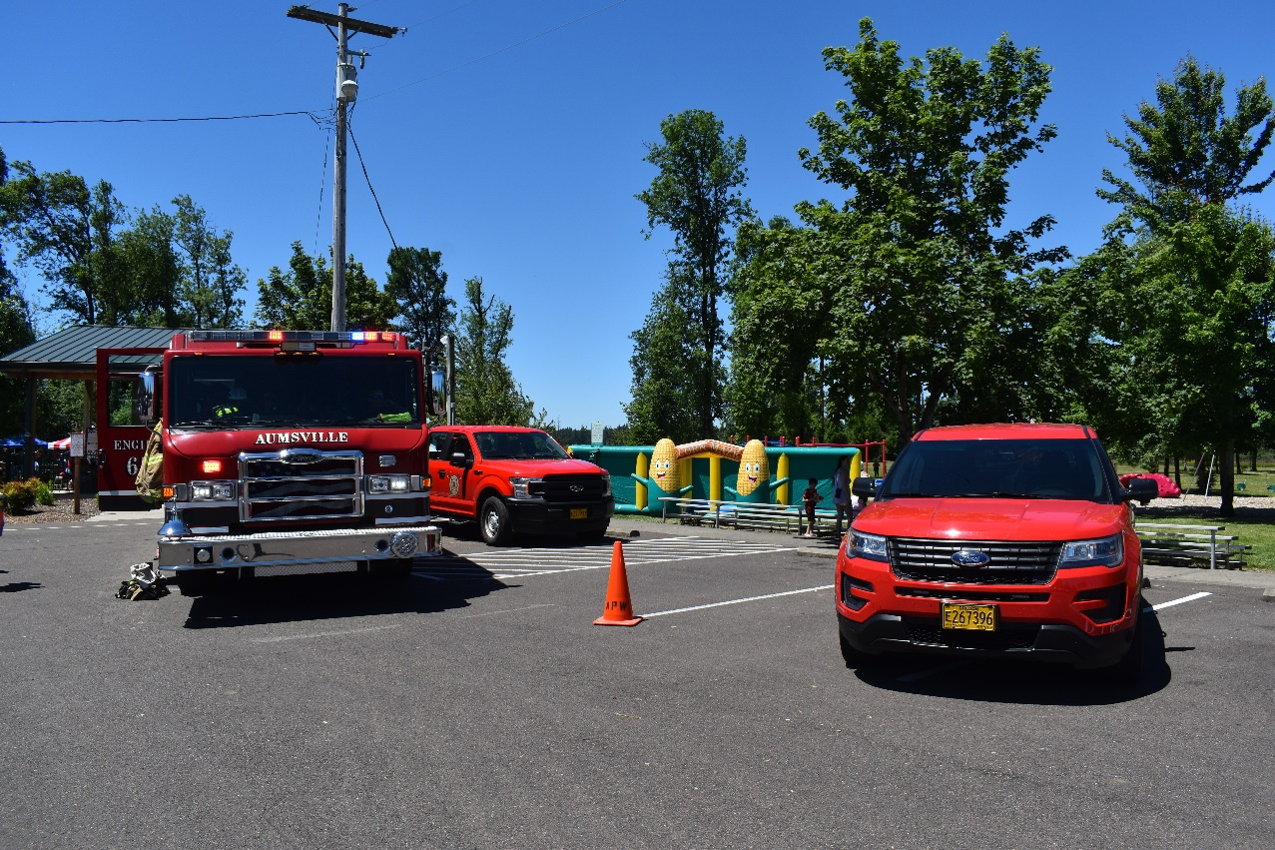
2022 Superhero Day

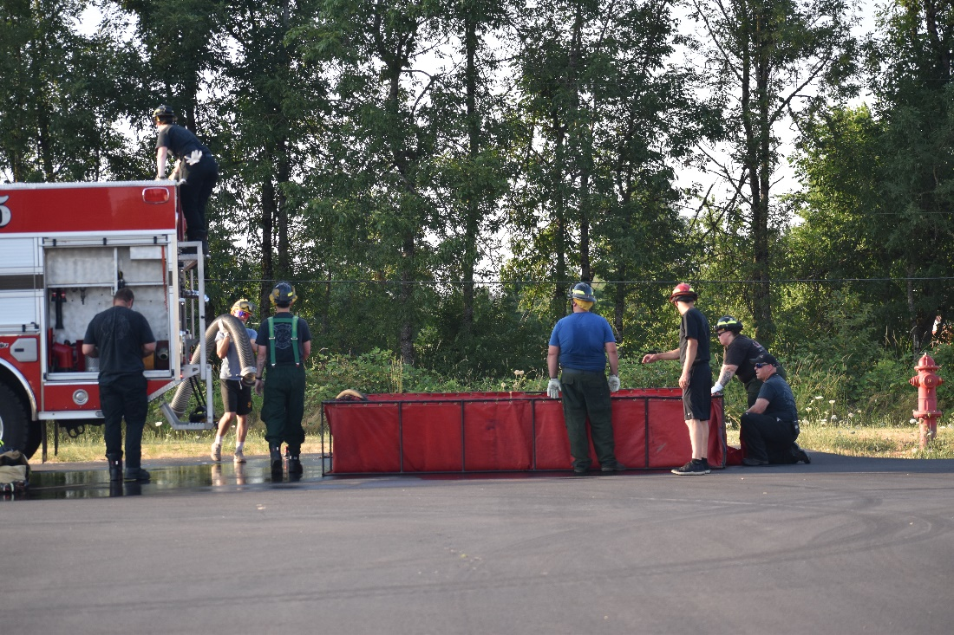

2022 Drill

Glossary

Account | A term used to identify an individual asset, liability, expenditure control, revenue control, or fund balance.
Accrual Basis of Accounting | The method of accounting where revenues and expenses are recorded when they are earned (whether or not cash is received at the  time or not).
Adopted Budget | Adopted, as used in the fund summaries within the budget document, represents the final budget adopted by the Board of Directors. The adopted budget is effective July 1. Subsequent to adoption; the Board of Directors may make changes throughout the year via resolutions.
Ad Valorem | In proportion to the estimated value of the goods or transaction. A basis for levying tax upon property.
Alarm | A call received by the Dispatch Center, which is then related to the appropriate fire station for emergency response.
ALS | Advanced Life Support. Emergency medical care that is a set of life-saving protocols and skills that extend beyond Basic Life Support.
Appropriations | A legal authorization granted by a legislative body to make expenditures and to incur obligations for specific purposes. In budget, an appropriation is limited in amount and time it may be expended.
Apparatus Operator | Rank above firefighter. In addition to performing all the assigned duties of a firefighter, an apparatus operator maintains the equipment and drives the apparatus. Also called Engineer.
Approved Budget | Approved, as used in the fund summaries, represents the proposed budget with changes made by the budget committee, if any.
Assess | To establish an official property value for taxation.
Assessed Valuation | The total taxable value placed on real estate and other property as basis for levying taxes. The assessed value is the lower of its real market value or its maximum assessed value.
Assets | Property or equipment owned that is regarded as having a value and available to meet debts and commitments.
Balanced Budget | A budget in which revenues equal expenditures for all funds presented.
Bond | A written promise to pay a specified sum of money at a specified future date (maturity date), along with periodic interest paid at a specified percentage. The difference between a note and a bond is the latter usually runs for a longer period and requires greater legal formality.
Bonded Debt | The portion of indebtedness secured by a bond issue. It is a written obligation contracted for local government purpose pursuant to law and to be paid out of taxes to be levied upon all property within its boundaries.
Brush Truck | Four-wheel drive engines with small pumps and water supply capabilities that are specifically designed for wildland-urban interface fires.
Budget | A plan of financial operation that includes an estimate of income and expenditures for a set period.
Budget Message | A general discussion of the proposed budget as presented in writing by the budget-making authority to the Board of Directors and Budget Committee members. The budget message should contain an explanation of the principal budget items, an outline of the government unit’s experience during the past period and its financial status at the time of the message, and recommendations regarding the financial policy for the coming period.
Capital Assets | Assets of significant value and having a useful life of several years.  Capital assets are also referred to as fixed assets.
Capital Budget | A plan of proposed capital outlays and the means of financing them for the current fiscal period. It is usually a part of the current budget. A Capital Program is sometimes referred to as a Capital Budget.
Capital Outlay | Expenditure for the acquisition of capital assets valued over  $5,000.
Capital Projects | Projects which purchase or construct capital assets.
Capital Projects for the Funds | A fund created to account for financial resources to be used for acquisition or construction of major capital facilities and/or designated fixed assets.
Capital Improvement Program | A plan for capital expenditures that are incurred each year over a fixed period of years to meet capital needs arising from the long- term work program or otherwise. It sets forth each project or other contemplated expenditure in which the government is to have a part and specifies the full resources estimated to be available to finance the projected expenditure.
Captain | Rank above Lieutenant. Responsible for the overall administration of his/her assigned station, including operational readiness, personnel supervision, and the station’s budget.
Chart of Accounts | The classifications system used by a governmental agency to organize the accounting for various funds.
Company | A work unit comprised of a piece of apparatus and its assigned personnel.
Current Funds | Resources of which are expended for operating purposes during the current fiscal period. In its usual application in plural form, it refers to General, Debt Service, and Enterprise Funds of a governmental unit.
Current Liabilities | Liabilities which are payable within a relatively short period of time, usually no longer than a year.
Current Taxes | Taxes levied and becoming due during the current fiscal period, from the time the amount of the tax levy is first established, to the date on which a penalty for nonpayment is attached.
Debt | An obligation resulting from the borrowing of money or from the purchase of goods and services. Debts of governmental units include bonds, time warrants, notes, and floating debt.
Debt Limit | The total amount of money that the district is authorized to borrow to meet its existing legal obligations.
Debt Service Fund | A fund established for the payment of interest and principal on general obligation debt.
Delinquent Taxes | Taxes remaining unpaid on and after the date on which a penalty for nonpayment is attached, even though the penalty may be subsequently waived and a portion of the taxes may be abated or canceled, the unpaid balances continue to be delinquent taxes until abated, canceled, paid, or converted into tax liens.
Depreciation | A reduction in the value of an asset with the passage of time, due to wear and tear.
Director | Director refers to an elected member of the Fire District’s Board of Directors.
Dispatch | The 9-1-1 agency responsible for receiving emergency and non- emergency calls and for sending the appropriate company to the call.
EMR | Emergency Medical Responder
EMS | Emergency Medical Services
EMT | Emergency Medical Technician. The state of Oregon has three levels, EMT-B (Basic) EMT-I (Intermediate) and Paramedic.
Engine | A piece of apparatus that pumps water, carries ladders, hoses, and medical supplies.
Equipment | Tangible property of a permanent nature (other than land, buildings, or improvements other than to buildings), which is useful in carrying on operations. Examples are machinery, tools, trucks, cars, furniture, and furnishings.
Expenditures | Is a payment with either cash or credit to purchase goods or services.
FEMA | Federal Emergency Management Agency. Employs more than 20,000 people nationwide to leverage a tremendous capacity to coordinate within the federal government to make sure America is equipped to prepare for and respond to disasters.
Fire Chief | Highest-ranking officer in the Fire District and is the Chief Executive within the organization. The Fire Chief reports directly to the Board of Directors.
Firefighter | Performs firefighting and rescue operations for combating, extinguishing, and prevention of fires, as well as for saving life and property.
Fiscal Year | A twelve-month period beginning July 1 and ending June 30 to use for financial reporting and budgeting.
Fixed Assets | Assets which are purchased for long-term use and are not likely to be used up or sold within the year.
Fund | An independent fiscal and accounting entity with self-balancing set of accounts, recording cash and/or other resources together with all related liabilities, obligations, reserves, and equities that are segregated for the purpose of carrying on specific activities attaining certain objectives.
Fund Balance | The difference between fund assets and liabilities reflected on the balance sheet or statement of net assets.
General Fund | A fund used to account for all transactions except those assigned for other purposes in another more specialized fund.
General Long-Term Debt | The debt taken which is payable after the period of one year on the date of the balance sheet.
General Obligation Bonds | A type of municipal bond in which the bond repayments are guaranteed by the total revenue generated by both tax revenue and revenue generated by various projects.
Gross Bonded Debt | The total amount of bonded debt and any short-term debt of a governmental unit represented by outstanding bonds before deduction of any assets available and earmarked for their investments.
Hazardous Material | Any substance or matter that is biological, chemical, radiological, and/or physical, which has the potential to cause harm to humans, animals, or the environment, either by itself or through interaction with other factors.
IT | Information Technology Services
Incident | An event involving a fire, medical emergency, hazardous material spill, technical rescue, or release/potential release of a hazardous material.
Interface | The area where more populated communities meet wildland or rural areas. This is area is difficult to protect from a fire perspective, due to unusual amount of vegetation surrounding the manmade structures (also called wildland/urban interface).
Intranet | Internal communications network based upon Internet technology used for departmental exchanges of information.
Internal Control | A plan of organization for purchasing, accounting, and other financial activities that is affected by the board of directors, management, and other personnel that is designed to provide:  - Functions to minimize risks and protect assets.  - Adherence to policies, rules regulations and laws.  - Ensure accuracy of records and encourages operational efficiencies.
Levy | To impose taxes, special assessments, or service charges for the support of governmental activities. The total amount of taxes, special assessments, or service charges imposed by a governmental unit.
LUCAS | Lund University Cardiopulmonary Assist System. This mechanical device helps to provides high-quality chest compressions as well as being able to sustain life-saving circulation during prolonged resuscitation attempts in situations such as patient movement and transportation.
Modified Accrual Basis | The basis of accounting that combines cash basis and accrual basis accounting. This form of accounting allows short-term events to be recorded utilizing the cash-basis method, and it records long-term events using the accrual method.
Municipal Corporation | Is the legal term used for a local governing body that includes cities, counties, and special districts. A municipal corporation has defined boundaries and a population and is usually organized with the consent of its residents.
Net Bonded Debt | The total bonded debt less accumulations of a sinking fund and all self-supporting debt.
Object Classification | To classify or group expenditures that are similar. Some examples are personnel services or equipment.
Operating Expenses | An expense that is incurred through normal operations. An example of an operating expense is the power bill.
Operating Statement | A statement summarizing the financial operations of a governmental unit for an accounting period as contrasted with a balance sheet which shows financial position at a given moment in time.
Paramedic | The highest level of training an EMT can reach in the State of Oregon.
PIO | Public Information Officer. Assists in the management of public affairs with Communication and activity between the Fire District and the General public. This is currently the duty of the Fire Chief.
PPE | Personal protective equipment that is used to minimize the exposure of hazards. This includes at a minimum turnouts, breathing apparatus, masks, and gloves.
PERS | The Public Employees Retirement System. A State of Oregon benefit pension plan for public employees.
Performance Measures | Specific quantitative measures of work performed within an activity or program (e.g., smoke detector program).
Program | A group of related activities performed by one or more organizational units for the purpose of accomplishing a function for which the district is responsible.
Request for Proposal | Also known as an RFP. Is a formal document that describes a project that a government agency uses to solicit and award a public contract for goods or services by requesting and evaluating competitive sealed proposals.
Rescue Unit | A smaller response unit staffed by a company officer and firefighter that primarily responds to medical emergencies.
Resources | The actual assets of a governmental unit, such as cash, taxes receivables, land, buildings, etc. Contingent assets such as estimated revenues applying to the current fiscal year not accrued or collected, and bonds authorized and un-issued.
Response | Actions taken by the Fire District in response to a citizen’s request for services. This includes the initial dispatch, travel time, and on- scene care of the patron.
Revenue | Is an increase to a fund’s assets that is generated from normal operations. Generally, they:  - Do not increase a liability (e.g., proceeds from a loan)  - Do not represent a repayment of an expenditure already made  - Do not represent a cancellation of certain liabilities  - Do not represent an increase in contributed capital.
SCBA | Self-Contained Breathing Apparatus. Is a respiratory device worn by firefighters to provide breathable air in a potentially dangerous environment where the air is oxygen deficient due to smoke, gases, etc.
SDAO | Special Districts Association of Oregon
Shift | A term used to describe the “on-duty” period for workers.
Support District Volunteer | A group of “on-call” citizens, who assist with various Fire functions, i.e., provide rehabilitation services at incidents, assist with various events, and perform clerical duties.
Tax Levy | Is a procedure used by local governments to collect money to pay a tax debt.
Tax Rate | The amount of tax levied for each $1,000 of assessed valuation.
Taxes | Compulsory charges levied by a governmental unit for the purpose of financing services performed for the common benefit.
Technical Rescue | Any kind of incident that requires specialized tools and skills for helping victims. This would include vehicle extrication or small space rescue.
Turnouts | Protective gear worn by firefighters consisting of coat and pants.
Unappropriated Fund Balance | Where the fund balance at the close of the preceding year is not included in the annual budget, this term designates that portion of the current fiscal year’s estimated revenues, which has not been appropriated. Where the fund balance of the preceding year is included, this term designates the estimated fund balance at the end of the current fiscal period.
Volunteer | A group of trained citizens who are “on call” as either a firefighter or member of the support team.
Water Tender | A specialized piece of apparatus that transports water from a water source to a fire scene.

Information obtained from Marion County’s GIS program.
Information obtained from ODOT Oregon Department of Transportation : Traffic Counting : Data & Maps : State of Oregon
Information obtained from https://censusreporter.org/profiles/16000US4103250-aumsville-or/
The District’s fiscal year commences July 1 and ends on June 30 of the following year (the “Fiscal Year”)
Represents the District indebtedness subject to the debt limitations, including both voter-approved general obligations and liabilities outstanding incurred under rental or lease-purchase agreements, including the Bonds. Source: Marion County Department of Assessment and Taxation, Aumsville Rural Fire Protection District
Population data from https://data.census.gov/cedsci/ with a 4% estimated annual increase.
Gross Debt includes all general obligation bonds and full faith and credit obligation debt.
Net Debt is Gross Debt less self-supporting limited and unlimited tax supported debt.
Only includes property-tax backed debt.
Information taken from http://realtor.com/ on 4/12/2023.

